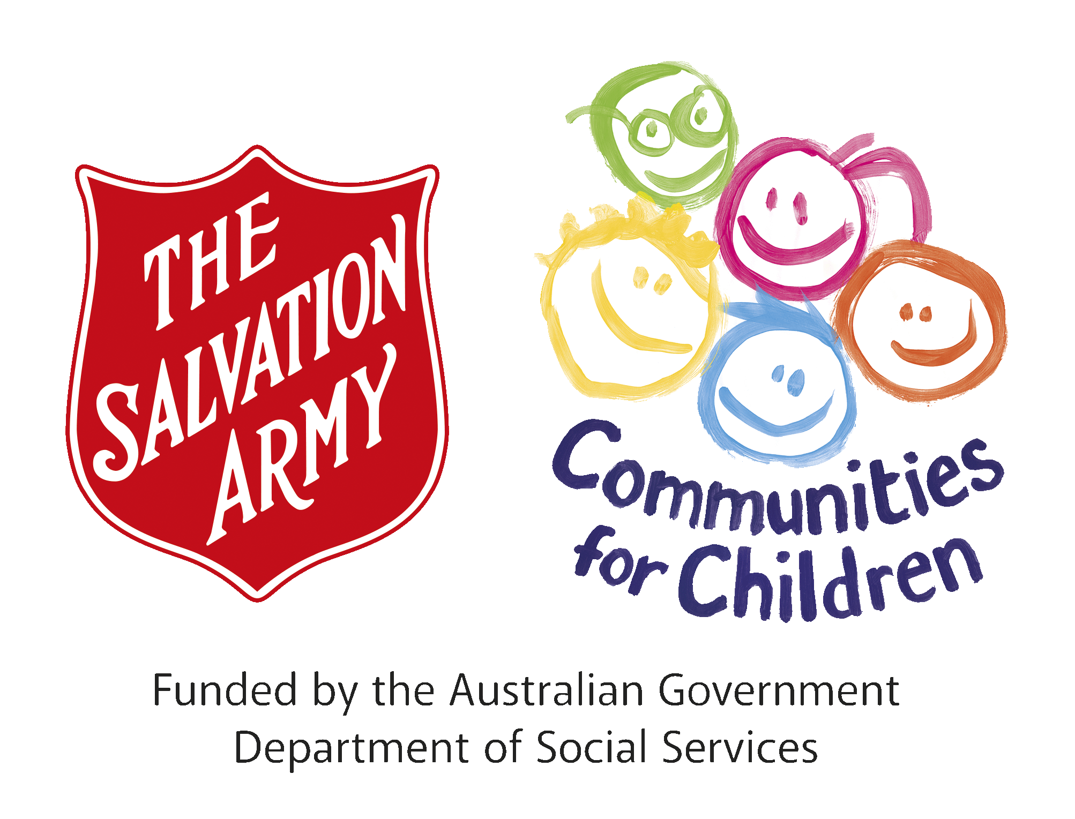
CfC South-East Tasmania, Small Grant Application
2025 – 2026 Guidelines
Timelines
Communities for Children Small Grant program is now open and will close 5pm, 31st January 2026. Successful grantees will be notified via email by Friday 20th February. Funds must be expended and acquitted by 31st July 2026.
Grant Guidelines
Grants are available for amounts between $1,000 and $3,000 and are open to Community Organisations to initiate or develop activities that improve parenting, safety and resilience, build community capacity and the health and wellbeing of families with children aged 0-12 years.
Eligibility
The Salvation Army, Communities for Children SE Tasmania (CfC) provides small grant funding to deliver activities and programs to communities in the Southern Midlands, Brighton, Derwent Valley and Central Highlands, Local Government Areas.
As a program, CfC is committed to listening, hearing and promoting the voices of our families, and our children, and this is our way of ensuring the small grant funding goes to where it needs to go.
Applications for a CfC Small Grant will need to demonstrate that the request for support contributes to
our focus areas/program ideas:
✓ resilience
✓ aspirations
✓ increase safety in communities
✓ school transitions (into primary school, out of primary school).
Applicants must have adequate public liability insurance for their proposed activity.
Who Makes the Funding Decisions?
Projects that meet The Salvation Army (TSA) and DSS requirements will be assessed by the CfC Facilitating Partner Team, with final funding decisions made by the Communities for Children Funding Sub Committee.

Exclusions
Applications are ineligible if the request for funding support is for any of the following:
• Scholarships or Bursaries
• Commonwealth, State government funded agencies
• Fundraising drives
• Duplication of existing programs or projects
• Upgrade or improve buildings or assets
• Individuals with a business benefit (unless private community service focussed business)
• Activities that are the responsibility of other funding programs.

Submitting applications
All applications must be submitted on the CfC SE Tas small grant applications form 2026, which can be downloaded from the CfC Se Tas website Small Grants | Tasmania Communities for Children | The Salvation Army Australia

Applicants who are awarded a grant will be required to enter into a service agreement with The Salvation Army. Compliance with the terms and conditions outlined in the agreement will be required. Should circumstances change and other funding sourced for the same project, The Salvation Army must be notified, and a variation submitted for approval by the Communities for Children Funding Sub Committee. In some cases, the grant payment may need to be returned.
For more information on the Communities for Children program, including accessing the grant applications guidelines, or application form, please visit our website:
www.cfctas.org.au
or email CfC SE Tas administration Coordinator Jo East jo.east@salvationarmy.org.au

