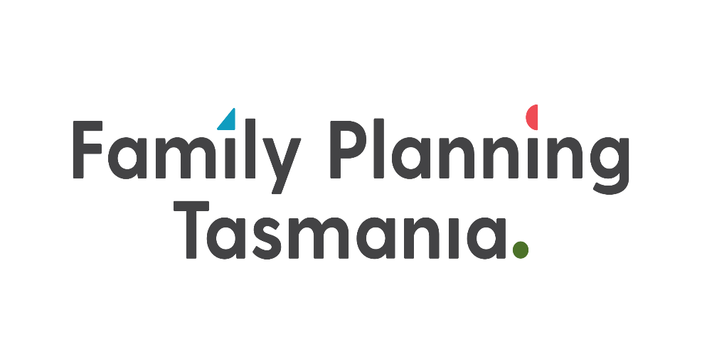

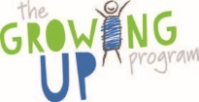

12 schools

"We should have this program throughout the year, more than once"!

"I loved the 2 x 30 minute sessions.
It made it engaging the whole time and ensured students didn't miss important info"

Parent & Carer Information Session Video Series
"Wow what a fantastic program" thank you!
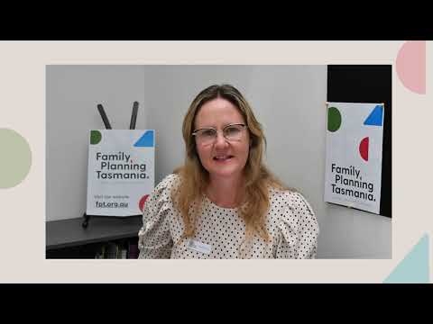

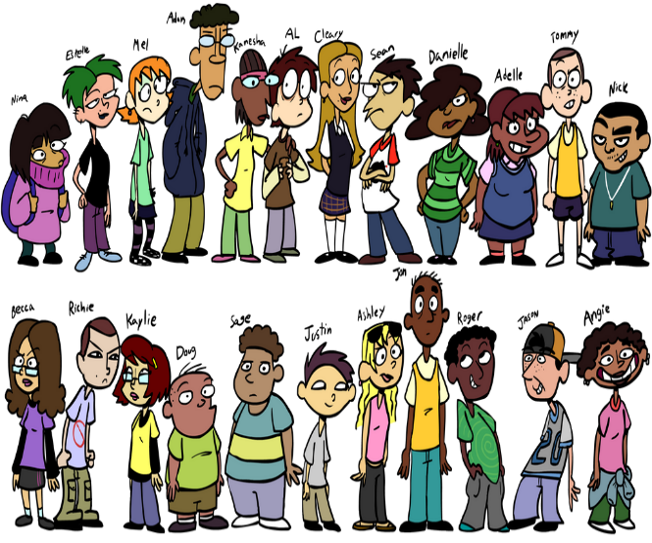
- 41 - Aboriginal & Torres Strait Islander students
- 5 Culturally and Linguistically Diverse students
- 142 Additional Needs students

1448
School Students

The Question Box
Where does a tampon go?

Do people have surgery to change their gender?
What is rape?
Why do erections just happen?
Do people lose confidence during puberty?

When will I get my period?
Is it normal to feel confused about my body image?
Why do I feel sad a lot?
Is it OK to like someone?
What is a dildo?
How do you stop an egg cell meeting a sperm cell?

What’s the difference between a bottom and an anus?

How does a penis get into a vagina?
Is horny the same as sexy feelings?
An example of questions received by our educators from students in grades 5/6

NEWS
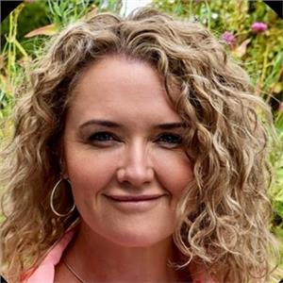
FPT new CEO – Lalla Mackenzie –A proud member of the Dalrymple tribe. Motivated and passionate – Up for a challenge!! Background – Telecommunication/National Apprenticeship System Project Management

Up Coming activities

- Tagari Lia have booked in their SoSafe - 27th of April and 4th of May. Specifically delivered in accordance with need (this is usually a 1 day 5 hour workshop)
- GUP Program – May-June
  - Westerway PS
  - Fairview PS
  - Campania DS
  - Fairview PS
- meetings for one on one sessions with Gagebrook Primary School, Herdsmans Cove Primary School and Brighton Primary School. All very keen for some of their students. Referral forms provided

Partner Opportunities
- HIPPY – talking to parent group about protective behaviours –
- Families Tasmania – Request for FPT to do a to do a 30 minutes Facebook Live Q & A session- Further discussion regarding session to be arranged.
- Possible “you show me yours and I’ll show you mine” for Partners
- Could/should we as collective partners join together (project) to design and build a “live case study”?

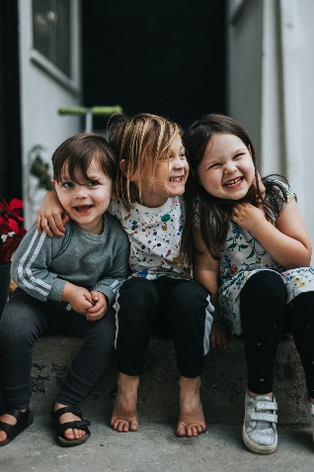
New Program/s
- Parent and carer workshop on how to talk to your kids (GUP related)
- currently under development
- Childhood Sexual & Social Safety – 3 hour workshop - This workshop is ideal for anyone working with children who requires an understanding of how to support them with their social and sexual safety, sexual development, sexual health and relationships.

Challenges

- Over the twelve months to the March 2023 quarter, the CPI rose 7.0%. This is impacting on service deliverables costs - Likelihood of this being recognised and additional $$$? If not what adjustments are being considered/negotiated
- Sustainability/succession planning in-case of………………..
- The old chestnut of SAMis reporting - still a challenge but working through it

- Brighton Primary school (in particular stated) that they wish they could have the Growing Up Program every year due to it’s importance and the ongoing issues that they have with some behaviours at the school. Due to not knowing about ongoing funding we were not able to offer them the program but the need and want is definitely there

