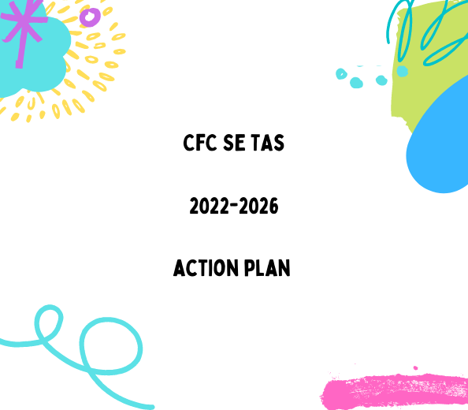

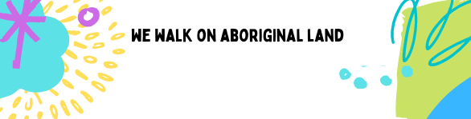
Communities for Children South-East Tasmania acknowledge and pay respect to the Tasmanian Aboriginal people as the traditional and original owners, and continuing custodians of this land on which we gather today and acknowledge Elders – past, present and emerging.
We acknowledge those who have passed before us and acknowledge Tasmanian Aboriginal people who are living and working in our Communities for Children activity areas, and we acknowledge that sovereignty has never been ceded.
We stand for a future that profoundly respects and acknowledges Aboriginal perspectives, culture, language and history. And a continued effort to fight for Aboriginal justice and rights paving the way for a strong future.

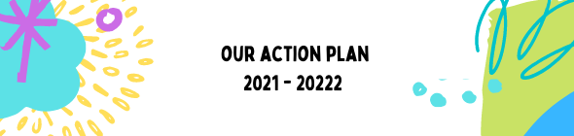

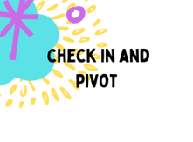
- Start the strat plan work by connecting in with our key stakeholder:
  - In person at a Strat Plan day
  - Online (survey monkey)
  - Face to face through our networks
  - Face to face through our stakeholder groups
  - Through the conversations with the collective impact project – Aboriginal Advisory Group – lead to an Aboriginal Family Worker and Aboriginal School Holiday program
- Once the goals are confirmed – start the process for the
  - Draft theory of change and program logic
  - EOI process for new Community Partners
  - Wrap up and exit existing Community Partners/existing plans
  - Get paperwork done for new Community Partners
- AWP work for July – December 2021
WINS
  - Through the conversations with the collective impact project – Aboriginal Advisory Group – lead to an Aboriginal Family Worker and Aboriginal School Holiday program

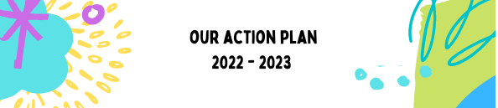
Welcome new Community Partners – bed them in with the Committee and CI practices
Embed referral and collaborative approach
Update AWP for DSS
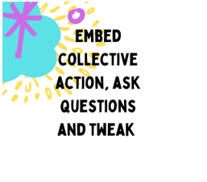
Finalise the Strat Plan document – including an update TOC and PL
Plan the consultation and actions in the Strat Plan
LISTEN LISTEN LISTEN – action what we can in collaboration with the community voices and energy
DISRUPT by thinking about how we do things, and doing them in a way that reflects current conditions
SUPPORT our families through the worldwide pandemic
GROW our networks our connections
SHARE information, knowledge, training, resources
BUILD IN – our community sustainability plans

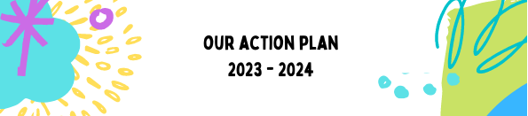
Continue testing the new program offerings with our community. Listen to our Community Partners and encourage them to grow, stretch, extend into the shape that aligns with their communities and with their growing skill set.
Bring our community members on board – sharing skills, encouraging, capacity building (and having our capacity built)
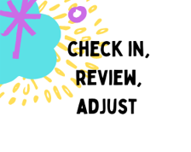
Check in to see how our communities are feeling – pivot, adapt, jiggle to improve our work – using our strong networks
Communicate, communicate, communicate – then share share share the information.
Keep skill sharing, training and opportunities happening in our communities.
Review the emerging community needs against our Community Partners, and adjust if necessary.
Review our Strategic Plan – update, edit, inform our path forward.
KEEP BUILDING IN – our community sustainability plans
Have our DSS midpoint assessment process done – and pass with flying colours.

Bed in any change, welcome all the input, celebrate our wins, strategise over our losses.
Welcome any new Community Partners, and partnerships to our program.
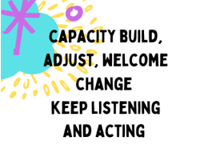
Up the training, up the skill sharing, up the community capacity building to see more community members leading our processes.
Check in to see how our communities are feeling – pivot, adapt, jiggle to improve our work – using our strong networks
Communicate, communicate, communicate – then share share share the information.
Keep skill sharing, training and opportunities happening in our communities.
Review the emerging community needs against our Community Partners, and adjust if necessary.
Review our Strategic Plan – update, edit, inform our path forward.

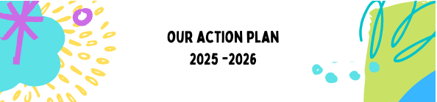
This final year can go two ways:
- Funding is discontinued
This would mean we’d be rolling back our services, building in and encouraging our sustainability plans to come to fruition.
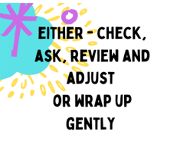
Do a deep data dive, and community feedback process, to really assess the wins, losses, gaps and opportunities we leave behind – to ensure our work isn’t lost.
Thank and celebrate with our communities, gently untangle relationship strings and encouraging future possibilities
Sharing of all our resources out to communities and organisations, to ensure nothing is wasted
OR 2. Our CfC funding is extended. Clearly, since our work is really long term work, breaking downs years of systemic and cyclic abuse, this is our best option.
This new funding period would offer CfC the opportunity to:
- Update this Strategic Plan with all the richness of the years combined
- Celebrate and adjust our Community Partners
- Do a listening round to really make sure our delivery, and our community sector delivery, is working
- Map, and mark in data how we’ve gone, and what’s left to target
- Check our goals – adjust and adapt as needed
- Update and review everything! What we’ve learnt from our 2021-2022 refresh is that changing and reviewing makes this fresh, effective, and current.

