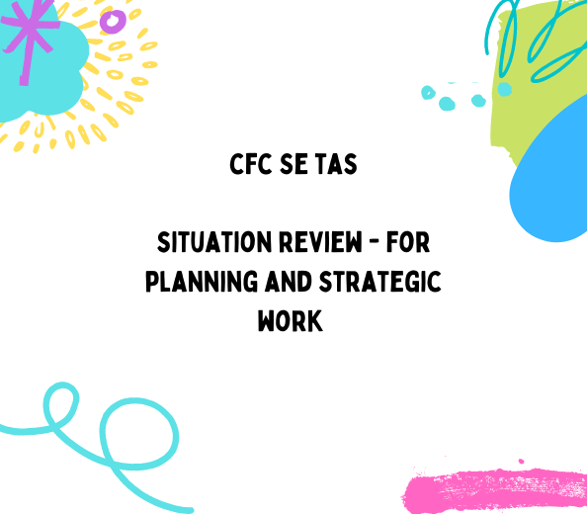

Communities for Children – media commentary

Brief

Conduct a desktop search of:
- media commentary on the Communities for Children (CfC) – South East Tasmania program
- general media commentary about its communities, i.e., children, youth, stigma, behaviour.

Search parameters

CfC South East Tasmania communities of:
- Southern Midlands – Bagdad, Campania
- Upper Derwent Valley/Central Highlands – Glenora, Westerway, Ouse
- Brighton – Bridgewater, Gagebrook, Herdsman Cove
- Derwent Valley – New Norfolk, Fairview

Commentary/posts that support key deliverables:
- Role of CfC. I.e., building on local strengths to meet the needs of individual communities, creating capability within local service systems.
- Funding Community Partners to provide services targeted to their community as identified by a local committee.
- Activities that support children and families affected by domestic and family violence may also be supported.

Level of parental and partner engagement and acknowledgement of the program. Partners include:
- Impact communities – Families and Schools Together (FAST) program
- Family Planning Tasmania – Relationship & Sexuality Education program
- Playgroup Tasmania – Smalltalk program
- Families Tasmania – rhyme and story time
- Engender Equality – the Shark Cage
- Uniting – Aboriginal Support Worker school program (Brighton)
- Kids in the Valley (Derwent Valley)
- Navigate Family Services Southern Midlands Hub
- Hobart City Mission Southern Midlands Community Development program
- Uniting Family Support Program (Central Highlands)

Review web/social media platforms for commentary, including mainstream media reporting. Search focussed on above parameters and a range of other tags, e.g. #communitesforchildren, Brighton, Central and Southern Highlands, Derwent Valley, Upper Derwent, children, community, Media, health outcomes, anti-social behaviour, Salvation Army, school, youth, students, Tasmania, Glenora, Bagdad etc.

Summary of commentary

CfC related

A social media desktop review of the Communities for Children South East Tasmania program found that:

- Promotion of program activity in Derwent Valley and Brighton communities is evident with some client engagement.
- Linkages between ‘Community Partner’ activity and the overarching program is not strong.
- No CfC commentary found in Southern Midlands or Upper Derwent communities, including each township (place) in these regions.
- The peak bodies such as TasCoss, Council of the Ageing and Volunteering Tasmania are promoting the benefits of the program.
- The Derwent Valley community is the most active and connected of the CfC communities, partly driven by FAST Tasmania and a strong youth network.
- Minimal parental engagement on the social media platforms reviewed.
- Minimal to no acknowledgement of the CfC program across all communities.
- No recent twitter or Instagram posts for Tasmania.
- No use of the #communitiesforchildren in Tasmania.

Broader community related

Southern Midlands – Bagdad, Campania

Some commentary and media for Bagdad talks about anti-social behaviour by young people.

Criminal activity is mentioned and there is a level of safety concerns apparent in individual posts but also in media reports.

Given its position, Bagdad reports driving offences frequently. Many of those visiting or driving through provided negative comments, confused by the name and its layout.

Social media posts demonstrate a strong community willing to help each other, e.g., provision of equine therapy to Bagdad Primary School students celebrated.

There is very little evidence of negative commentary for Campania. Social media posts tend to celebrate it being a wine/paddock to plate region.

Upper Derwent Valley/Central Highlands – Glenora, Westerway, Ouse

Commentary by members of these townships is welcoming and supportive in the social media space, particularly around advertising job opportunities and celebrating youth/student achievement at the Glenora State School.

There is no significant mention of disadvantage or anti-social behaviour other than driving offences.
However, media reports focussed on access to health services (Ouse) and the mental health challenges of farmers due to the 2016 floods.

Across all townships there is positive messaging about youth and high and primary school children’s events through the Derwent Valley Youth Futures Action Group (D’FaT)

Brighton – Bridgewater, Gagebrook, Herdsman Cove

Commentary for the Brighton townships is noticeably different to other LGA’s examined. Media reporting for Bridgewater often relates to criminal activity (violence, arson, illicit drugs etc.). It is often reported as one of the most disadvantage areas in Tasmania.

In Gagebrook, most reports are about anti-social behaviour by youths as well as major crime (arson, drugs, and shootings).

Some positive commentary exists around student activity at Gagebrook primary school.

Health outcomes are seen as poor for residents in these townships. For example, according to research reported, Bridgewater/Gagebrook has the worst smoking rate in Australia and lower life expectancy compared with other Hobart suburbs.

Media reports mention that stigma is a real problem for those who live in the region, particularly Bridgewater. One parent felt that her residential address meant she was often judged by services, referring to her bad parenting skills rather than the need for intervention services for her son. Students of the Jordan River Learning Federation (JRLF) also reported feeling ‘postcode stigma’.

There are great examples of strong positive community run and government investment initiatives that buck this perception, e.g., community group tackling dumping on the Derwent River, Bridgewater Bridge, or student achievement at JRLF. What is notable is that when there is positive media coverage, stigma, and the level of disadvantage of Bridgewater is generally always mentioned.

Herdsmans Cove commentary is slightly more varied. While it has commentary on criminal activity, its housing market is reported to be taking off. Again, the local primary school is positively promoted.

Derwent Valley – New Norfolk, Fairview

Derwent Valley media commentary is diverse and generally positive. Media reports tend to focus on New Norfolk’s’ growth and increased housing investment.

Access to adequate health care is a significant issue like that in Ouse.

Social media reports celebrate youth achievements, and this is fuelled by D’FaT.

There is evidence of an active community network in the social media commentary examined.

Some ideas

A coordinated communications strategy that seeks but is not limited to:

- Encouraging parents to engage in CfC programs and services in their townships via a social media campaign.
- Improving branding and use of the #communitiesforchildren by all Community Partners and other key strategic partners
- Using Twitter to support mainstream media interest
- Encouraging champions at the local town level to celebrate achievements
- Promote individual stories via social media to encourage others to participate
- Use personal stories to normalise and reduce stigma amongst parents
- Partner with existing township service information hubs to promote the program, e.g., connectingderwentvalley.com.
- Conduct individual interviews in each township to determine level of stigma and what type as this is often not reported. For example, we know that mental health in these communities is an issue but there is a gap in commentary on this topic.
- Focus and promote the positives of township activity.

Benefits

A stronger coordinated promotional effort will be beneficial to meeting CfC obligations because:

- Evidence shows that parental engagement via social media works
- Publicly available information of your activities and achievements provides assurances to your funding agency that their funds are being well spent
- Demonstrates your efforts in supporting take up of CfC program offerings
- Promotes the benefits of ‘Community Partner’ programs
- Assists in stigma busting for the townships you support.

