### 

### Facilitating Partner Details

| Service Area Name | South – East Tasmania – Brighton, Southern Midlands, Derwent Valley, Central Highlands |
| --- | --- |
| FP Name | The Salvation Army – Communities for Children – South East Tas |
| FP Contact Name | Tanya Brooks-Cooper |
| FP Contact Title | Manager |
| Address | 115 Central Ave, Derwent Park |
| State/Territory and Postcode | TAS 7009 |

### Community Strategic Plan

| **Date Communities for Children Committee agreed to Community Strategic Plan** |  |
| --- | --- |
| **Name of Facilitating Partner Authorising Officer** | Stacey Milbourne, State Manager, Children and Families Programs, Tasmania |
| **Signature of Facilitating Partner Authorising Officer** |  |

### DSS Use

| **Date of Submission to DSS** |  |
| --- | --- |
| **Date of DSS approval** |  |
| DSS Delegate Name |  |
| DSS Delegate Position |  |
| DSS Delegate Signature |  |



*Communities for Children South-East Tasmania acknowledge and pay respect to the Tasmanian Aboriginal people as the traditional and original owners, and continuing custodians of this land on which we gather today and acknowledge Elders – past, present and emerging.*

*We acknowledge those who have passed before us and acknowledge Tasmanian Aboriginal people who are living and working in our Communities for Children activity areas, and we acknowledge that sovereignty has never been ceded.*

*We stand for a future that profoundly respects and acknowledges Aboriginal perspectives, culture, language and history. And a continued effort to fight for Aboriginal justice and rights paving the way for a strong future.*

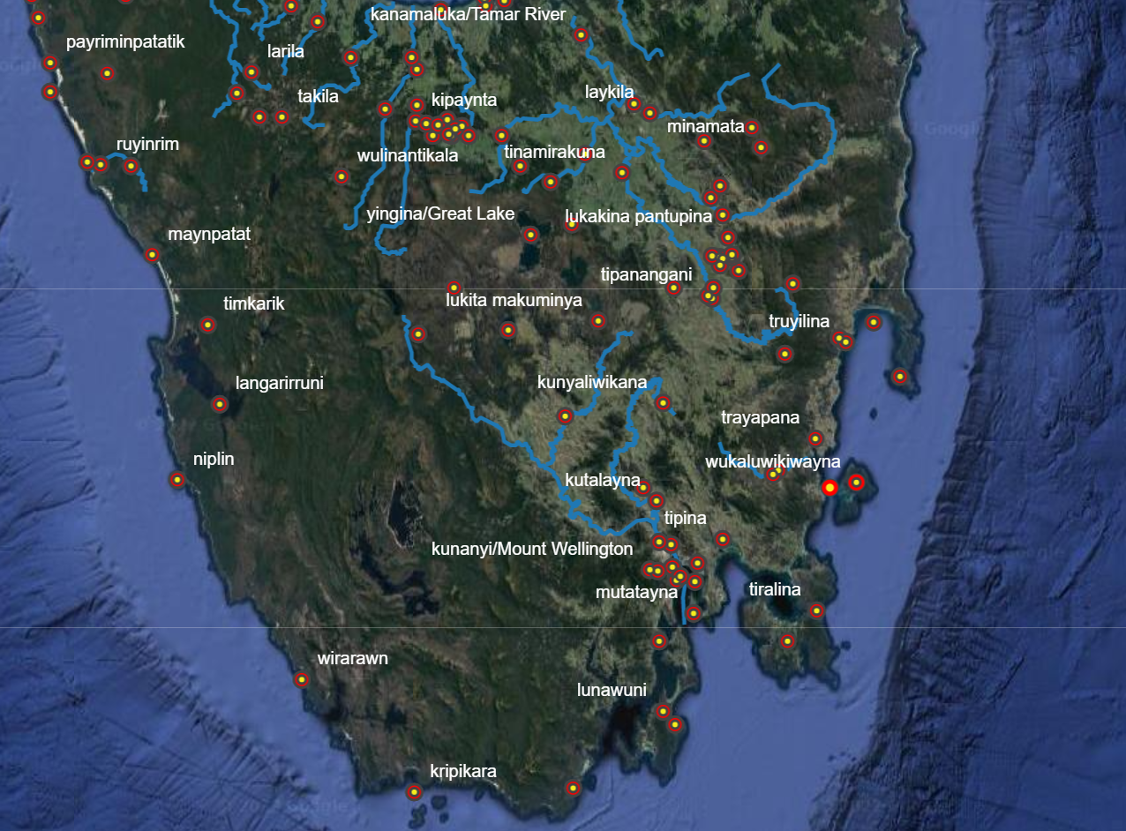

<http://tacinc.com.au/pk/GIS/index.html#8/-42.068/146.566>



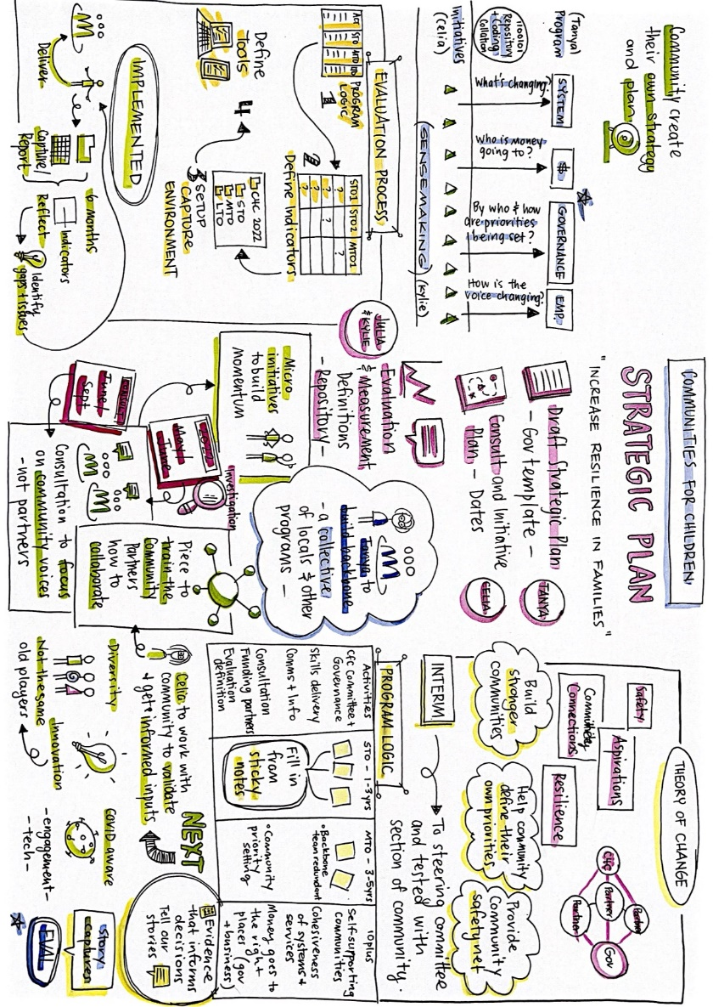



Communities for Children (CfC) - South East Tasmania delivers programs and activities in the LGA’s of:

* Southern Midlands
* Upper Derwent Valley/Central Highlands
* Brighton
* Derwent Valley

Communities for Children delivers programs and activities for families with Children in the 0-12 year age group that address the priority areas of **Safety**, **Resilience**, **Aspirations and Community Connections** and the Communities for Children Facilitating Partner objectives of:

* To improve the health and well-being of families and the development of young children, from before birth through to age 12 years, paying special attention to:
* Healthy young families — supporting parents to care for their children before and after birth and throughout the early years;
* Supporting families and parents — support for parents to provide children with secure attachment, consistent discipline and quality environments that are stable, positive, stimulating, safe and secure;
* Early learning — provide access to high quality early learning opportunities in the years before school; provide early identification and support for children at risk of developmental and behavioural problems; assist parents with ways they can stimulate and promote child development and learning from birth; and
* School transition and engagement - support children and families to make a smooth transition to school and work with local schools to assist children and families with their ongoing engagement with school.

The program aims to create **strong child-friendly communities** that understand the importance of children and apply this capacity to maximise the health, well-being and early development of young children at the local level.

Communities for Children- South-East Tasmania functions as a collective impact project, with a strong, vibrant backbone team and innovative, ethical, connected Community Partners. We work collectively, sustainably and we prioritise place-based initiatives to meet our goals in an inclusive and respectful manner.

Our 'Collective Leadership Table' is named our CfC Steering Committee, made up of our Community Partners, Community Members and people interested in working collaboratively towards our goal of:

## **“Families thriving in strong, safe communities”**

All our funding decisions are made by the Funding Committee, who are Steering Committee Members. We do not allow Community Partners to join the Funding Committee, to avoid conflicts of interest.

We are committed to working towards ‘Closing the Gap’, breaking inter-generational trauma cycles, proactively challenging domestic and family violence and using innovative ways to create change. Our Communities for Children program is engaged in genuine systemic change work through the kutalayna Collective Table, Connected Beginnings program delivery and working with our local Aboriginal Advisory Groups.

We will implement and develop this work in partnership with our communities, community networks, government agencies and collectively address systemic issues in a progressive way.



We have an active Facebook presence - <https://www.facebook.com/CfCSouthEastTasmania>

And we are on the web at <https://www.salvationarmy.org.au/tasmaniac4c/>



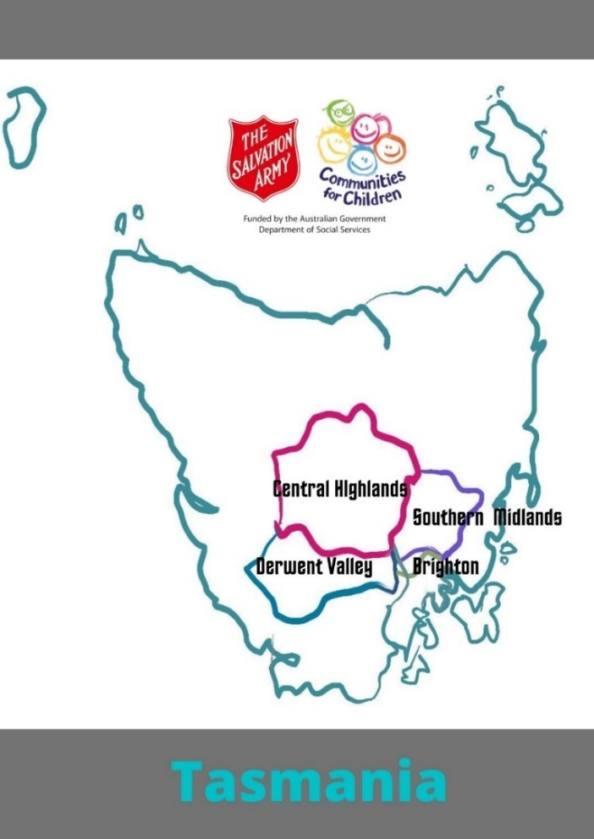

Communities for Children South East Tas is committed to working **with** families and communities, using place based, collective impact practices to support change around:

* Community connections
* Resilience
* Safety
* Aspirations

At the same time connecting the pieces together to build child safe communities for everyone.

We support schools and our partners to work in meaningful, sustainable ways with our families to innovatively roll out evidence based, best practice programs and projects with robust evaluation processes in place.

The success of our work is based on The Salvation Army’s (TSA) Communities for Children FP engaging skilled, committed and innovative community partners, and training and resourcing our communities and partner services.   We will achieve positive impact by participating in action-based community networks, and by delivering programs and projects that have been asked for and endorsed at the local community level.

The TSA CfC FP team leads by walking along side, building capacity and engaging with families and children to make sure program delivery is aligned with community needs. We value flexibility, sustainability, innovation and best practice in all service areas. We provide funding for gaps in service delivery where possible, and work proactively to connect communities to services that are available to them.



Communities for Children SE Tas has been operating in the Brighton, Derwent Valley, Central Highlands and Southern Midlands local government areas of Tasmania for the last 16 years.

These communities are facilitating communities, with their unique people, stories and history. They are geographically diverse, and each with their own strengths and opportunities.

The CfC program, like the community, has changed, grown and adapted as the years have moved on, as the overall CfC goals and rules have emerged, and as our communities have changed and grown.

For all the changes in structure, funding, people, the focus of our program has always been:

* Connections – our program is connected to the community, to the sector, to other CfC’s and to The Salvation Army to work collaboratively
* Nimble – our program is nimble, and is set up to respond quickly to issues and strategies
* Strength based – we honestly believe our communities have the people, skills and ability to effect their own change – we are here to provide support and opportunities
* Focussed on building and growing what is already present in the community – which is why our goals of safety, resilience, aspirations has stood the test of time and has been reaffirmed over and over. Recently we added Community Connection to our goals, as an overarching umbrella to hang these working tasks and goals under, and that has provided us with our new focus for 2021-2026.

**You’ll notice this strategic plan is a plan to plan.**

**That’s because things change in our communities at a rapid pace.**

**COVID-19 and a worldwide pandemic has quickened this pace.**

**What’s current today – isn’t what even last week looked like. And that’s ok.**

**Our plan is to stay in touch with our communities. Adjusting, listening, trailing, changing, as their needs change.**

**Our underlying strategy to build community connections, grow aspirations, build community safety and encourage resilience are versatile, and a constant. As our focus lens they provide us with the umbrella to contemplate our program delivery, test our outcomes, and guide the community on what information they give us.**



Communities for Children SE Tas is committed to:

|  |  |  |
| --- | --- | --- |
| **Goal** | **How** | **Who** |
| Sharing knowledge | Through formal learning opportunities, and through our quality, skilled Community Partners operating in our communities | CfC FP  CfC Community Partners  CfC Networks  Community members sharing with other community members |
| Connecting | By being strategic in our messaging, and the messaging of our Community Partners.  By being consistent with sharing information – and ensuring our information is interesting, current, accessible and accurate. | CfC FP  CfC Community Partners  CfC Networks |
| Creating Opportunities to try new things | By working with our CfC networks and partners to make things happen (driven by community of course!) | CfC FP  CfC Community Partners  CfC Networks |
| Plugging our communities, partners, networks into external training | CfC has a strong network across Tasmania and Australia and that opens the doors to some amazing, cost effective, training to skill build our sector and people. | CfC FP  CfC Community Partners  CfC Networks |
| CfC FP and CPs as a resource | Our team, and The Salvation Army, has a huge range of skills, abilities, knowledge, and we actively promote, share, connect to share, build and use this knowledge to support our program delivery. | CfC FP  CfC Community Partners  CfC Networks |
| CfC FP participation in national/international events | Our CfC FP will participate in processes like the AIFS Expert Panel, DSS processes, national conferences (including celebrating our great local collaborations by presenting) to ensure we are cutting edge, at the front, and leading the way in community lead change.  What is this Expert Panel?  The Families and Children Expert Panel Project (the Expert Panel) was established to help service providers to plan, implement and evaluate programs for families and children using evidence-based approaches. The Expert Panel is managed by the Australian Institute of Family Studies (AIFS) on behalf of the department. Information relating to the Expert Panel is shared via the Child Family Community Australia (CFCA) Information Exchange (also managed by AIFS). | CfC FP  CfC Community Partners  CfC Networks |

**It only takes one person to mobilise a community and inspire change. Even if you don't feel like you have it in you, it's in you.** Teyonah Parris



**Communities for Children - SE Tas works in the community for everyone.**

**Everyone is welcome to attend our programs, come to our training sessions, join our Community Consultation Committees. If you have a connection to a family in our area, we want to have a connection with you.**

**Our programs are FREE! We fund, collaborate, leverage, partner, connect and ensure all our offerings are inclusive, free (and cost effective), and welcoming.**



The CfC FP is the non-government organisation with whom the Australian Government enters into a grant agreement to manage and facilitate the Communities for Children initiative for the Service Area.

For us, this is The Salvation Army Tasmania, and Communities for Children sitting in the head office at Derwent Park. The Salvation Army have held the CfC funding for the last 16 years and the strong relationships with our communities has gone from strength to strength.

The CfC FP is responsible for overall facilitation and management of the Communities for Children initiative within the Service Area. This includes being responsible for ensuring the Community Partner and any other sub-contracting arrangements are consistent with the obligations of the grant agreement, and that the subcontractors comply with all legal obligations in the grant agreement as well as all policy requirements described in the Operational Guidelines.

The CfC FP facilitate relationships with and between stakeholders, facilitate processes and establish management and administrative frameworks for ensuring the success of the initiative. At all times, CfC FPs are responsible for ensuring that any work provided meets the requirements of the grant agreement.

The CfC FP will regularly review the performance and need for activities provided by Community Partners, especially when preparing Activity Work Plans, to ensure services continue to meet the needs of the community.

**This relationship is active, unlike so many sub-contracting arrangements. The CfC FP is flexible and responsive, funding, resourcing, piloting and addressing community issues at a community level.**

The team is dynamic, and inclusive. It’s small and works hard. It coordinates connections, research, networks, and links people and places together.

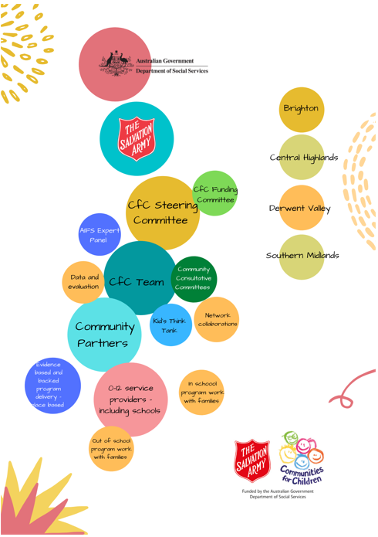



Communities for Children SE Tas works in our communities for our communities.

Wherever we can we have community members guiding us, working with us, leading our programs.

We tailor our approaches at the local level, providing communities with the opportunity to provide input into the development of approaches that best reflect their circumstances.

**We know this works!**

* **When we get our local-level approach right,**
* **within a strong evidence-based framework,**
* **including a focus on capacity building for the local community;**

**Our work is effective in supporting children and families wellbeing.**

Our CfC program and Community Partners network WIDELY with:

* other providers under the Families and Communities Program, particularly those funded under the Families and Children Sub-Activity
* services funded by state and territory governments that service our communities (and sometimes out of our community to see what other people are doing to keep our ideas and responses fresh)
* Services Australia (and their outreach workers, social workers and key ‘supportive’ team members)
* medical services such as general practitioners (including Primary Health Tasmania)
* mental health services
* alcohol and other drug services
* family violence services
* legal assistance services
* family law courts
* domestic and family violence services
* homelessness services
* education services
* housing services, and
* any other relevant services, such as financial counselling and health services.

**“Never doubt that a small group of thoughtful, committed, citizens can change the world. Indeed, it is the only thing that ever has.”  
― Margaret Mead**

Our CfC ACTIVELY:

* recognises, supports and works with community-led change initiatives (we are lucky enough to have the Kutalayna collective, Connected Beginnings, links with Burnie Works and the Future Impact Group (Georgetown)
* recognise and support local and cultural leaders and governance arrangements
* support and participate in the design and implementation of community-led change strategy
* consider within the parameters of the operational guidelines and grant requirements, opportunities to align service provision and communication to the community’s strategy, including community needs, goals and solutions
* share data, evidence and learnings to improve outcomes for children, families and communities
* are fair, open and transparent in engaging with Aboriginal and non-Aboriginal stakeholders and organisations
* participate in work that examines the system (beyond programs) to create better outcomes and
* build relationships, collaboration and leverage investments and impacts.

**CfC SE Tas welcomes everyone to our table! To:**

* **Work with us to create community lead change**
* **To disrupt, challenge and impact on systems that aren’t working**
* **To join in the work, take the lead, create new actions**
* **Plan with us, and give us feedback on planning**
* **Work with us to share information and break down silos**
* **To actively, warmly, energetically share referrals and information**

“Don't Just”  
  
Don't just learn, experience.  
Don't just read, absorb.  
Don't just change, transform.  
Don't just relate, advocate.  
Don't just promise, prove.  
Don't just criticize, encourage.  
Don't just think, ponder.  
Don't just take, give.  
Don't just see, feel.  
Don’t just dream, do.  
Don't just hear, listen.  
Don't just talk, act.  
Don't just tell, show.  
Don't just exist, live.”  
― **Roy T. Bennett,**[**The Light in the Heart**](https://www.goodreads.com/work/quotes/49604402)



As we’ve explored and asked questions of our stakeholders, partners and communities we’ve discovered our broad goals of:

* Community connection
* Community safety
* Building resilience
* Building aspirations

Offer our program scope to address the gaps, the opportunities, and work collaboratively with our networks.

Our data dive attached captures the heart of the work we are doing in a very clinical sense, and our overall program drivers that include:

* Sustainable planning
* Skill sharing
* Community asset building
* Strong networks and referrals
* Connecting and collaborating with our partners.

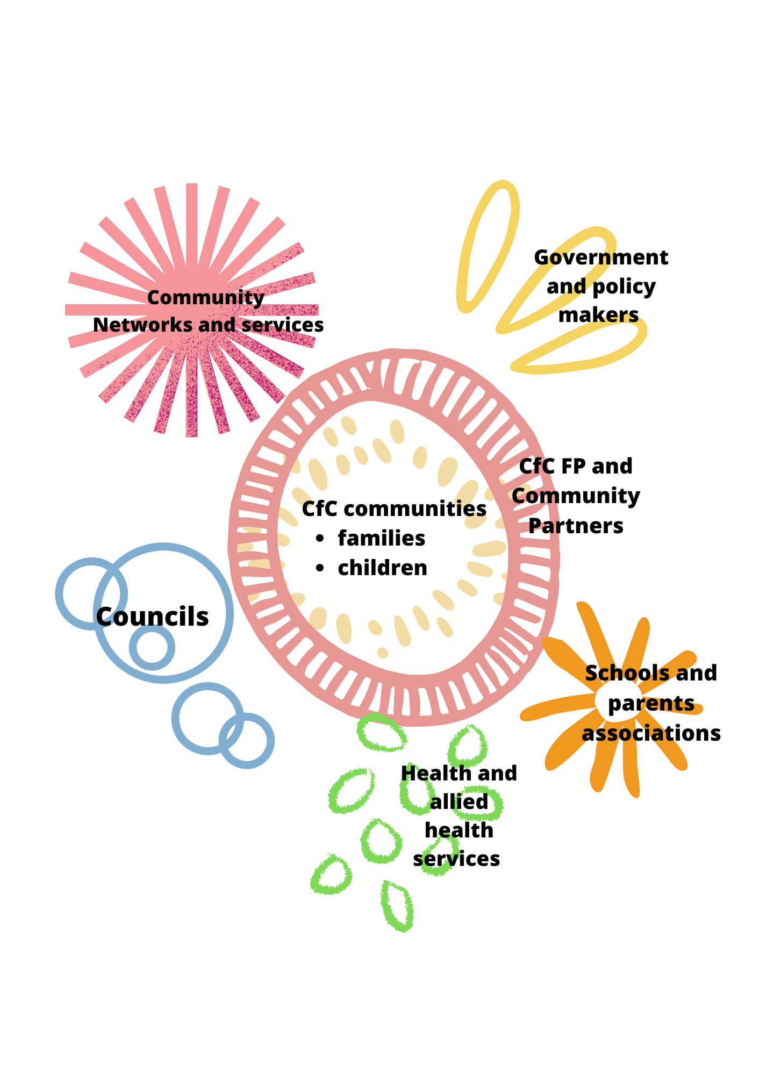

|  |  |  |
| --- | --- | --- |
| Goal | How | Who |
| A networked, connected CfC | CfC FP and CP’s will actively participate in networks to ensure we are connected, engaged, collaborative | CfC FP  CfC Community Partners  CfC Networks |
| Supported community organisations and networks | CfC FP and CP’s will attend, resource, skill share as part of our plan to grow capacity and connection in our communities. Where we can, we will invite our networks to join and connect in with existing groups. | CfC FP  CfC Community Partners  CfC Networks |
| Get up to date information | CfC will consult in timely, appropriate, considerate ways to test our program goals, successes, services in with our key stakeholders. Information gathered will be shared appropriately. | CfC FP  CfC Community Partners  CfC Networks |
| Breaking down silos | As a CfC we will work across the community and the sector to share and connect everyone together – so our families have a streamlined access to services and responses in a timely way. | CfC FP  CfC Community Partners  CfC Networks |



CfC FPs fund services that are designed to assist vulnerable children and families in disadvantaged communities, with a particular focus on children at risk of poor outcomes or at risk of abuse and neglect. This includes, and prioritises, those who are hard to reach.

Our programs are funded to support all families and children, and we aim to focus on activities that support:

* families with children at risk of abuse or neglect
* families experiencing disadvantage or vulnerability (including those with culturally and linguistically diverse backgrounds)
* Aboriginal and Torres Strait Islander clients

We also are working on including programs that are open to Dads and encourage connected parenting for all families.



**The world needs new leadership, but the new leadership is about working together.**

[**Jack Ma**](https://www.brainyquote.com/authors/jack-ma-quotes)

The one thing we’ve learnt in our many years of work in the Communites for Children space is that nothing is locked in.

Everything can change.

Our Strategic Plan that fits now, might not fit next year.

And we are ready for that, and ready to do the work to pivot, adapt, adjust, celebrate, consider, deliberate, and move in other directions.

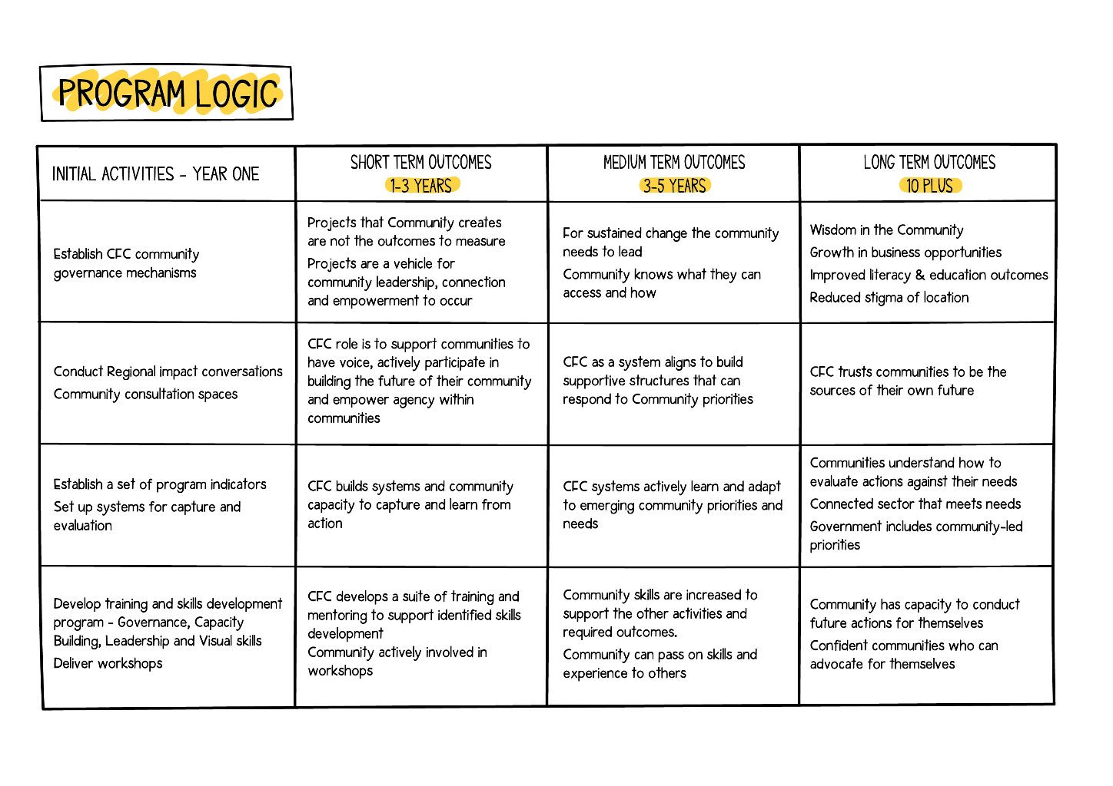



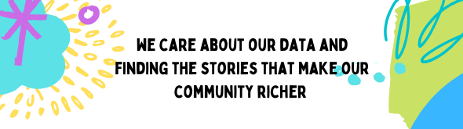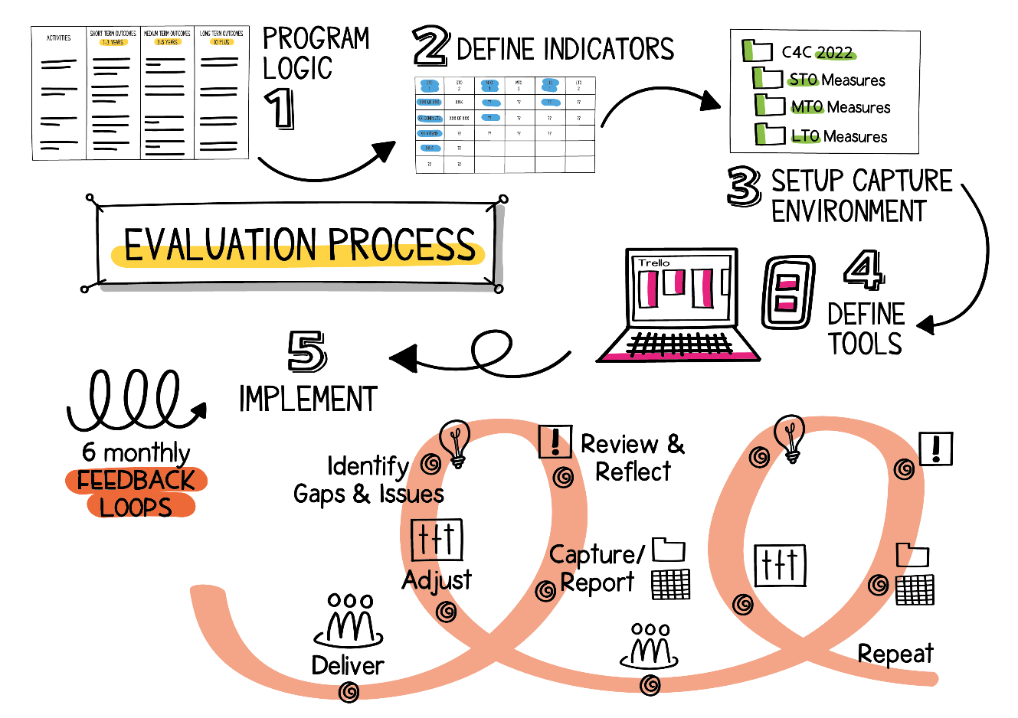

Actively supports gathering, sharing, using and verifying our data directly with our community and our partners.

*‘With the rise in deepening and expanding public engagement globally, the importance of community engagement has become pivotal for well-functioning, twenty-first century democracies. Constructive relationships between communities and the institutions of government make community engagement not only desirable, but necessary and viable as it is likely to lead to more equitable, sustainable public decisions and improve the liveability of local communities. This is why community engagement is important for individuals, public organisations, and governments alike.*

*Where traditional, executive-led approaches are ineffective, community engagement is important in its collaborative approach to the design and/or delivery of services. For the complexity of issues in any given community – where traditional approaches have been ineffective if non-inclusive in the extreme – community engagement enables better understanding of communities’ needs and aspirations*

## ***Community engagement builds and sustains cohesive communities***

*Community engagement is important because it is primarily, part of a dialogue where organisations and communities can make decisions to create social capital.*

*Compelling stories of the importance of community engagement range from creating (or indeed preventing) change in local policies and service provisions that not only enrich everyday lives and liveability of communities, but help shape and envision a community’s future, bringing with it not only wider societal change but global impacts.*

*Sally Hussey –* [*Bang the Table*](https://www.bangthetable.com/why-is-community-engagement-important/#:~:text=Community%20engagement%20increases%20the%20visibility,their%20towns%2C%20cities%20and%20neighborhoods.)

Our data collection will include:

* SAMIS
* SCORE
* Anecdotal – stories, pictures, community responses, school updates, partner updates

This will assist us in building a narrative around program success that isn’t just numbers, but around our people and our communities.



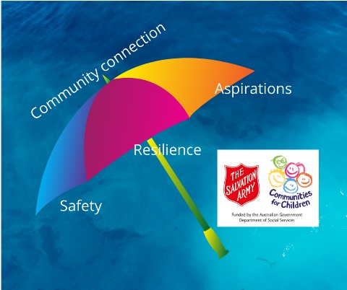

Our CfC SE Tas goals have been with us for many years, because they work. We tested them again with our communities in 2021 and this plan we’ve added community connection as over overarching goal – to build on our growing community safety, building resilience and offering opportunities to create some aspirations.

How we will do this is outlined in our Theory of Change.

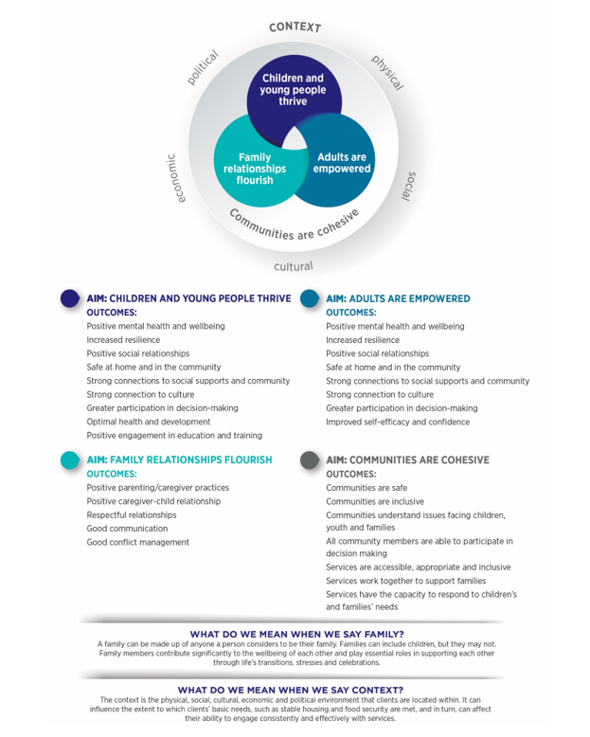



Our CfC is going through a period of change as we move more into a collective impact working style to reflect the changes that are taking place in our communities. Covid has had quite an impact on how our families feel, how they connect and how everyday things have changed.

Schools have been through some real changes throughout this pandemic, including periods of parents and carers tutoring their children at home, a mix of attendance style, limited parent engagement at school, to working through the pandemic in the classroom.

Service delivery has also been pivoting like a pinwheel in the wind, mixing up how delivery looks to keep families and workers safe. More and more services are delivered online – which is great for social distancing, but is a challenge with Tasmania’s high rates of digital disadvantage, and despite the NBN being fully rolled out, there are still blackspots that limit connectivity in many of our areas.

Our ‘Steering’ Committee has some new members, new faces and new skills.

Our refresh of Community Partners means we have new faces, and new skills at the table.

Our membership is getting more diverse, and we have families and communities giving us their wisdom through:

* Community Consultation Committees
* Our Community Partners
* Network meetings (including the recently formed Derwent Valley Family and Youth Network)

Our on the ground committees give us a meaningful way of engaging with our people – which means we connect where they are, around what they are wanting to see happen.

Our CfC FP and Community Partners have strong relationships with our Aboriginal communities, and we are privileged to have membership who identify as Aboriginal, and who lead strong community programs in the community on our panel. We also connect in regularly with the Kutalayna collective groups and have been supported by the Aboriginal Advisory Group.

Our DSS representatives is included on the CfC Committee in an ex-officio capacity.

Our Funding Committee is a strong group of committed, connected, CfC Committee members. They are knowledgeable, thoughtful, and strong critical thinkers. We thank them for taking the time to really work through how our program grows and develops.

Our Committee does a range of work with us, and that might include assisting the CfC FP to:

* consult with the wider community on community strengths, issues and needs;
* analyse and assess information from consultations and a range of other data sources to identify areas of need;
* determine evidence-based solutions to priority needs;
* develop linkages within the local service system;
* monitor progress and review performance; and
* develop the Community Strategic Plan and Activity Work Plans and Activity Work Plan Reports.

The CfC FP stays in touch with the Committee and in the style of collective impact work, encourages fearless and frank conversations, knowledge sharing, and as we learn to work together, critical conversations that will make our program more connected and more resilient.



In 2021, when CfC SE Tasmania was funded for an additional 5 years the decision was made to:

* meet with our communities and key community partners to check our program goals, and progress, and our way of doing business
* seek feedback about how CfC and our Community Partners were doing in the eyes of our community (we did this in anonymous surveys, talking one on one, asking in network meetings, talking to our Community Partners, talking to our schools and key stakeholders)
* do a call out for new community partners – to freshen up contracts that had been in place since 2017 (things have changed so much since then)

This decision lead to some swift internal pivoting – to ensure we were ready for delivering a program that listens, hears and connects with our communities and really reflects changes that are happening in a pandemic world.

The Strategic Planning process confirmed our goals of:

* Community Connection
* Building community safety
* Encouraging resilience
* Building aspiratons

Still really resonated with everyone – they are broad, they build a base, and they connect.

These goals also really aligned with the work DSS wants us to do, and the words/work being done in the Department of Education Tasmania, where our families connect in with.

The call out for new Community Partners was done in late 2021 and the Funding Committee did many hours working through the applications, tweaking their applications, working through endless spreadsheets around allocating the funding, and ensure the new Community Partners were the ones that would walk with us on this journey.

As a program we are aware this means we are building our Strategic Plan and our Work Plan after we’ve put on new Community Partners, but the gaps and struggles that were in place with a tired delivery system, plagued with many one year roll overs in funding, changing people, changing communites, meant we felt this was the best plan of attack.

And at writing this report, we think it was worth the quick pace. We reallly thank our Community Partners who didn’t move forward with us for their time, their skills, their commitment and their passion. They built us a base, a connection, and did amazing work.

Our 2022-2023 Community Partners are on a shorter contract this time, as we test this new model, see what our communities want, be nimble with the changes as they happen – think COVID 19!) came on board in January 2022.

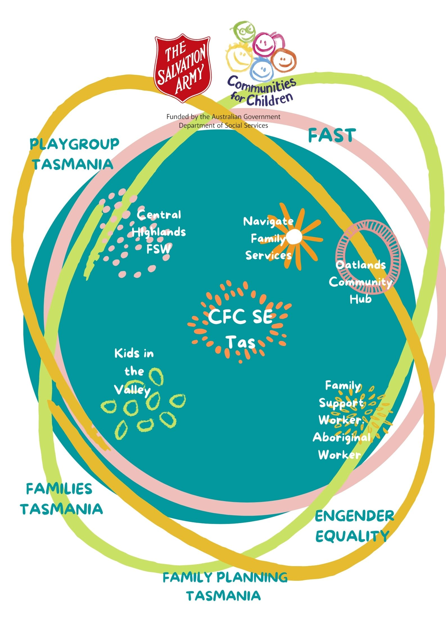

Things you’ll notice:

Our regioanl areas have had an increase in place based delivery.

Our new Community Partners offer a range of different services to our community members – all identified and tested in the communities we work in.

We have an emerging, strong, Aboriginal family support component to our communites. This was a community idea, a need, a gap, we’ve been able to work to make happen.

Our Community Partners have joined a program committed to working collaboratively – and that will see our program, their programs, amd our communities thrive.

So let’s meet them.

**Brighton, Southern Midlands, Central Highlands, Derwent Valley**  
  
**Family Planning Tas** will be providing support to families across all of our service areas by delivering:

* The Growing Up Program
* Relationships and Sexuality Education for young people with additional needs
* SoSAFE Program
* And a mix of group, family and individual supports in schools and community.

**Workskills** (Impact Communities) will be delivering [FAST](https://aus01.safelinks.protection.outlook.com/?url=https%3A%2F%2Fsalvationarmy.us17.list-manage.com%2Ftrack%2Fclick%3Fu%3D84d66d24979efc9d4dff118e9%26id%3Da842891270%26e%3Dee334d8781&data=04%7C01%7Ctracey.turale%40ths.tas.gov.au%7C80fcab4f8cc84ad5a3de08d9c41f5d5f%7C126fd8932f1f4b50beff2f146cbb7740%7C0%7C0%7C637756461257965612%7CUnknown%7CTWFpbGZsb3d8eyJWIjoiMC4wLjAwMDAiLCJQIjoiV2luMzIiLCJBTiI6Ik1haWwiLCJXVCI6Mn0%3D%7C3000&sdata=RnbbK0o5OGfbJnj6KUKSKh9ujvz3pUas1%2FCNnQsFxO8%3D&reserved=0)  (Families and Schools Together) program across our whole 4 areas, which focuses on building relationships between families and schools, empowering parents to become involved in their child's education and development. We are also partnering to pilot the Community Leaders Program to empower community members with leadership skills.  
  
**Playgroup Tas** will be rolling out the new [s](https://aus01.safelinks.protection.outlook.com/?url=https%3A%2F%2Fsalvationarmy.us17.list-manage.com%2Ftrack%2Fclick%3Fu%3D84d66d24979efc9d4dff118e9%26id%3D1eef1c9c8e%26e%3Dee334d8781&data=04%7C01%7Ctracey.turale%40ths.tas.gov.au%7C80fcab4f8cc84ad5a3de08d9c41f5d5f%7C126fd8932f1f4b50beff2f146cbb7740%7C0%7C0%7C637756461257965612%7CUnknown%7CTWFpbGZsb3d8eyJWIjoiMC4wLjAwMDAiLCJQIjoiV2luMzIiLCJBTiI6Ik1haWwiLCJXVCI6Mn0%3D%7C3000&sdata=aOYbGdDpv9l7%2BY0QtOUB4G2bOOHe2Dm6bY5WEP4pwXQ%3D&reserved=0)[malltalk program](https://aus01.safelinks.protection.outlook.com/?url=https%3A%2F%2Fsalvationarmy.us17.list-manage.com%2Ftrack%2Fclick%3Fu%3D84d66d24979efc9d4dff118e9%26id%3D6ca9ed890b%26e%3Dee334d8781&data=04%7C01%7Ctracey.turale%40ths.tas.gov.au%7C80fcab4f8cc84ad5a3de08d9c41f5d5f%7C126fd8932f1f4b50beff2f146cbb7740%7C0%7C0%7C637756461257965612%7CUnknown%7CTWFpbGZsb3d8eyJWIjoiMC4wLjAwMDAiLCJQIjoiV2luMzIiLCJBTiI6Ik1haWwiLCJXVCI6Mn0%3D%7C3000&sdata=xnI8h7Gf7zaq3MYh6b4GwLoiR%2BhF0hnQ5lHVHBXTcIc%3D&reserved=0)[,](https://aus01.safelinks.protection.outlook.com/?url=https%3A%2F%2Fsalvationarmy.us17.list-manage.com%2Ftrack%2Fclick%3Fu%3D84d66d24979efc9d4dff118e9%26id%3D5177339110%26e%3Dee334d8781&data=04%7C01%7Ctracey.turale%40ths.tas.gov.au%7C80fcab4f8cc84ad5a3de08d9c41f5d5f%7C126fd8932f1f4b50beff2f146cbb7740%7C0%7C0%7C637756461257965612%7CUnknown%7CTWFpbGZsb3d8eyJWIjoiMC4wLjAwMDAiLCJQIjoiV2luMzIiLCJBTiI6Ik1haWwiLCJXVCI6Mn0%3D%7C3000&sdata=HrX3Qy%2FDDf6kuGK7xiavkt3Ho%2Ff69ftNwoOl1c9jfIc%3D&reserved=0) that will be offered across all areas, focusing on enhancing the quality and quantity of parental communication and interaction.  
  
**Families Tas** will be operating across all service areas, offering: [Parent Child Mother Goose](https://aus01.safelinks.protection.outlook.com/?url=https%3A%2F%2Fsalvationarmy.us17.list-manage.com%2Ftrack%2Fclick%3Fu%3D84d66d24979efc9d4dff118e9%26id%3D64b672dca6%26e%3Dee334d8781&data=04%7C01%7Ctracey.turale%40ths.tas.gov.au%7C80fcab4f8cc84ad5a3de08d9c41f5d5f%7C126fd8932f1f4b50beff2f146cbb7740%7C0%7C0%7C637756461257965612%7CUnknown%7CTWFpbGZsb3d8eyJWIjoiMC4wLjAwMDAiLCJQIjoiV2luMzIiLCJBTiI6Ik1haWwiLCJXVCI6Mn0%3D%7C3000&sdata=i80L4LWZ75x3P39y0N0pD5kPHreLpaylbsAoH4F1s4g%3D&reserved=0) which we’ve renamed Rhyme & Storytime. This includes some online delivery, some face to face, some pop ups, and some general encouragement that music helps connections.

**Engender Equality** will be hosting [The Shark Cage](https://aus01.safelinks.protection.outlook.com/?url=https%3A%2F%2Fsalvationarmy.us17.list-manage.com%2Ftrack%2Fclick%3Fu%3D84d66d24979efc9d4dff118e9%26id%3De1da75861a%26e%3Dee334d8781&data=04%7C01%7Ctracey.turale%40ths.tas.gov.au%7C80fcab4f8cc84ad5a3de08d9c41f5d5f%7C126fd8932f1f4b50beff2f146cbb7740%7C0%7C0%7C637756461258121404%7CUnknown%7CTWFpbGZsb3d8eyJWIjoiMC4wLjAwMDAiLCJQIjoiV2luMzIiLCJBTiI6Ik1haWwiLCJXVCI6Mn0%3D%7C3000&sdata=gPV2%2BiYDKdzPqjpMXxvO2y5v%2B26uppYGNJm76jJvZ8s%3D&reserved=0), a powerful program designed to help understand violence against girls and women.   
  
**Brighton**  
  
**Uniting Tas** Family Support Program will see the continuation of 1:1 support for families in Brighton, including a new **Aboriginal Family Support Worker**, and a **Brighton Aboriginal School Holiday Program.**  
  
**Central Highlands**  
  
**Uniting Tas**new Family Support Worker position working out of Ash Cottage. This position is a new one, and will deliver some 1:1 support, some program work, some after school activities and maybe even some school holiday activities.   
  
**Southern Midlands**  
  
**Kristy Ingram** and **Martine Batt** will be offering family support and referral support through the **Navigate Family Services** in Kempton. This service will support families in Kempton and surrounds, and work in and out of school to improve outcomes. They are also going to include some after-school and school holiday programs.  
  
**Oatlands Hub – Hobart City Mission will be offering a range of services, including after school care, school holiday programs, emergency relief, coordinating services visiting, supporting local groups, community garden space and so much more.**   
  
**Derwent Valley**

**Sarah Davidson** will continue to work with us to deliver a range of support to students aged 6-12 who are living in the New Norfolk and its surrounds. Her program will include:

* [Drumbeat](https://aus01.safelinks.protection.outlook.com/?url=https%3A%2F%2Fsalvationarmy.us17.list-manage.com%2Ftrack%2Fclick%3Fu%3D84d66d24979efc9d4dff118e9%26id%3D236ecec50d%26e%3Dee334d8781&data=04%7C01%7Ctracey.turale%40ths.tas.gov.au%7C80fcab4f8cc84ad5a3de08d9c41f5d5f%7C126fd8932f1f4b50beff2f146cbb7740%7C0%7C0%7C637756461258121404%7CUnknown%7CTWFpbGZsb3d8eyJWIjoiMC4wLjAwMDAiLCJQIjoiV2luMzIiLCJBTiI6Ik1haWwiLCJXVCI6Mn0%3D%7C3000&sdata=QoVdzSCnwPucVpxkpwzijxkzC5BA52N9Qer%2BNMaaLFM%3D&reserved=0)
* [Friends for Life](https://aus01.safelinks.protection.outlook.com/?url=https%3A%2F%2Fsalvationarmy.us17.list-manage.com%2Ftrack%2Fclick%3Fu%3D84d66d24979efc9d4dff118e9%26id%3D21fcc393f7%26e%3Dee334d8781&data=04%7C01%7Ctracey.turale%40ths.tas.gov.au%7C80fcab4f8cc84ad5a3de08d9c41f5d5f%7C126fd8932f1f4b50beff2f146cbb7740%7C0%7C0%7C637756461258121404%7CUnknown%7CTWFpbGZsb3d8eyJWIjoiMC4wLjAwMDAiLCJQIjoiV2luMzIiLCJBTiI6Ik1haWwiLCJXVCI6Mn0%3D%7C3000&sdata=cOsi1jlHOnYZyC4CmRkPBlessxFZZmjp8IQfTW9nG8g%3D&reserved=0)
* Moving Up programs
* School holiday programs
* and school transitions

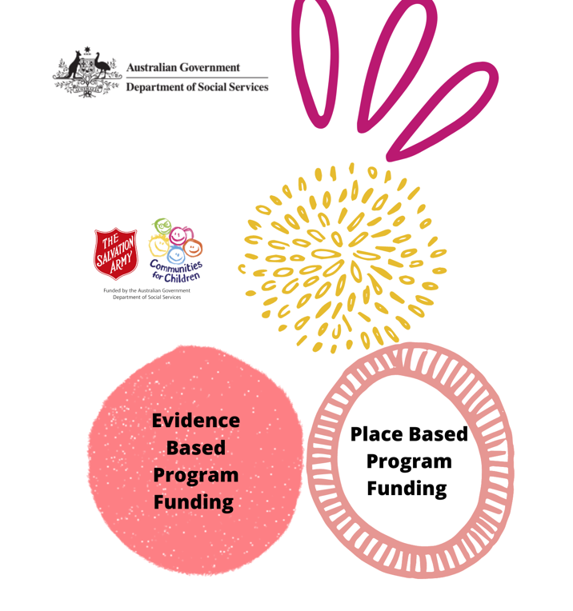



The Salvation Army has been the Facilitating Partner for Communities for Children for the last 16 years.

This plan outlines our work, our learnings, and our action research loops for the period 2021-2026.

Our program aims to support families, strengthen relationships, improve the wellbeing of children and young people and increase participation of people in community life to enhance family and community functioning.

T**he objectives of the Families and Communities Program and the Families and Children Activity align with objectives in the:**

[**National Agreement on Closing the Gap**](https://www.closingthegap.gov.au/national-agreement)

[**Closing the Gap Targets and Outcomes**](https://www.closingthegap.gov.au/national-agreement/targets)

[**National Framework for Protecting Australia's Children**](https://www.dss.gov.au/the-national-framework-for-protecting-australias-children-2021-2031)

[**National Plan to Reduce Violence against Women and Their Children 2010-2022.**](https://www.dss.gov.au/women/programs-services/reducing-violence/the-national-plan-to-reduce-violence-against-women-and-their-children-2010-2022)

Under our funding agreement with DSS our CfC program will actively participate and support the work and the goals of the overarching policies put in place by the Federal government.

As a collective we are also committed to working to make strides in state-based initiatives including:

### [Safe homes, families and communities](https://www.communities.tas.gov.au/children/safehomesfamiliescommunities) - Tasmania's action plan for family and sexual violence 2019-2022

[**It takes a Tasmanian Village**](https://wellbeing.tas.gov.au/tasmanias-child-and-youth-wellbeing-strategy-0-25-year-olds-it-takes-tasmanian-village-launched)– Tasmania’s first Child and Youth Wellbeing Strategy for 0-25-year olds.



We are avid communicators at Communities for Children for a few reasons:

* We believe knowledge is power
* We believe in skill sharing
* We love keeping people in the loop
* Disadvantage is disrupted when people are provided with the tools to change things

To that end we have:

* A very full, resource rich website
* A vibrant and busy Facebook page
* A growing list of subscribers to our enews
* An emerging Facebook group for our engaged CfC people

We actively:

* Read local news and scroll Facebook groups to connect, share and resource
* Attend networking meetings – and build networks where there are gaps (Derwent Valley Family and Youth Network)
* Support and attend local community events
* Monitor local social media groups for comments and community sentiment

To build on how we network in a worldwide pandemic we have:

* Made our events smaller, or outside
* Moved online where that is accessible to everyone

To continue the connection movement, we will:

* Explore and evaluate communication methods
* Try new things – like online speed networking events
* Ask for feedback and get reviews – then pivot our work accordingly
* Try all the ways – like printing and pinning on notice boards!



CfC targets those in the community who need us the most. This can include:

* families with low incomes
* young-parent families
* jobless families
* sole-parent families
* Aboriginal and Torres Strait Islander families
* families from culturally and linguistically diverse communities
* families with a parent (or child) who has a disability, and
* families experiencing problems with housing, domestic violence, substance abuse, mental health or child protection.

Our Community Partners are committed to developing services that are accessible and relevant for marginalised and disadvantaged families.

CfC works closely with our Aboriginal networks, to support Aboriginal families. We are actively engaged with collective impact projects, and in our communities to ensure our Community Partners and program collectively delivers the support our communities need.

Our programs all focus on being inclusive, widely advertised, shared, linked, connected and working as a whole movement.

Where we can, we will fund place-based projects and people. Where we can’t, we will fund, or implement, sustainable outreach to connect our families into appropriate support.

For more information consider this work:

* “Engaging Marginalised and Vulnerable Families” Centre for Community Child Health Policy Brief no 18.
* “Are disadvantaged families ‘hard-to-reach’? Engaging disadvantaged families in in child and family services” by Myfanwy McDonald, Australian Institute of Family Studies CFCA Practice Sheet, and other CFCA resources at <https://aifs.gov.au/cfca/topics/engaging-hard-reach-families>
* “This is Community Innovation” [Community Innovation](https://www.tamarackcommunity.ca/library/topic/community-innovation), [Community Change](https://www.tamarackcommunity.ca/library/topic/community-change), [Galen MacLusky](https://www.tamarackcommunity.ca/library/topic/galen-maclusky) <https://www.tamarackcommunity.ca/library/this-is-community-innovation>



**The world needs new leadership, but the new leadership is about working together.**

[**Jack Ma**](https://www.brainyquote.com/authors/jack-ma-quotes)

The one thing we’ve learnt in our many years of work in the Communites for Children space is that nothing is locked in.

Everything can change.

Our Strategic Plan that fits now, might not fit next year.

And we are ready for that, and ready to do the work to pivot, adapt, adjust, celebrate, consider, deliberate, and move in other directions.



Communities for Children – SE Tasmania will lead connections in the community and family sector. We will live the adage that ‘it takes a village’ and we will work actively to disrupting disadvantage through consciously

Our Community Partners will be committed to the practices of collective impact, which includes creating strong relationships and warm referral pathways.

Our CfC program will actively participate, and drive, connections in all our areas, to build and grow networks that work together, connect strongly, and partner to effect real change.

CfC will actively train, support, create opportunities for networking, to ensure this connection is living, thriving and has room to grow, change and adjust as our partners and communities change and develop through the funding period.



Communities for Children SE Tas lives, breathes and actively practices safeguarding children and families practices and processes in all our work. We lead from the front using trauma informed practices, sharing information and breaking down barriers around access.

We also commit to calling out practices and behaviours that don’t align, support or promote the safety of our families in our communities.

We won’t just talk about it – we will walk it.

Why? Because the Royal Commission into Institutional Responses to Child Sexual Abuse highlighted the need for organisations to adopt child safe practices including appropriate screening of staff, mandatory reporting and adoption of the National Principles for Child Safe Organisations.

In response, the Australian Government introduced the *Commonwealth Child Safe Framework* (the Framework), a whole-of-government policy that sets minimum standards for creating and embedding a child safe culture and practice in Commonwealth entities and Commonwealth funded third parties. We have worked these practices into our contracts and into our daily work.

All services funded under the Communities for Children Facilitating Partner activity must ensure activities conducted comply with the National Principles for Child Safe Organisations and other action for the safety of children, and relevant checks and authority. Under this clause, you are required to:

* submit an annual Statement of Compliance stating you have implemented the National Principles for Child Safe Organisations;
* complete an updated risk assessment to identify the level of responsibility for children and level of risk of harm to children;
* have an updated risk management strategy; and
* provide training and a compliance regime.

We work closely with our Community Partners to ensure this is all in place, and a living conversation, with learnings shared and valued.

Further information on the Framework and providers’ obligations is available on the [National Office for Child Safety website](https://pmc.gov.au/domestic-policy/national-office-child-safety) and the Australian Human Rights Commission’s [Child Safe Organisations website](https://childsafe.humanrights.gov.au/).



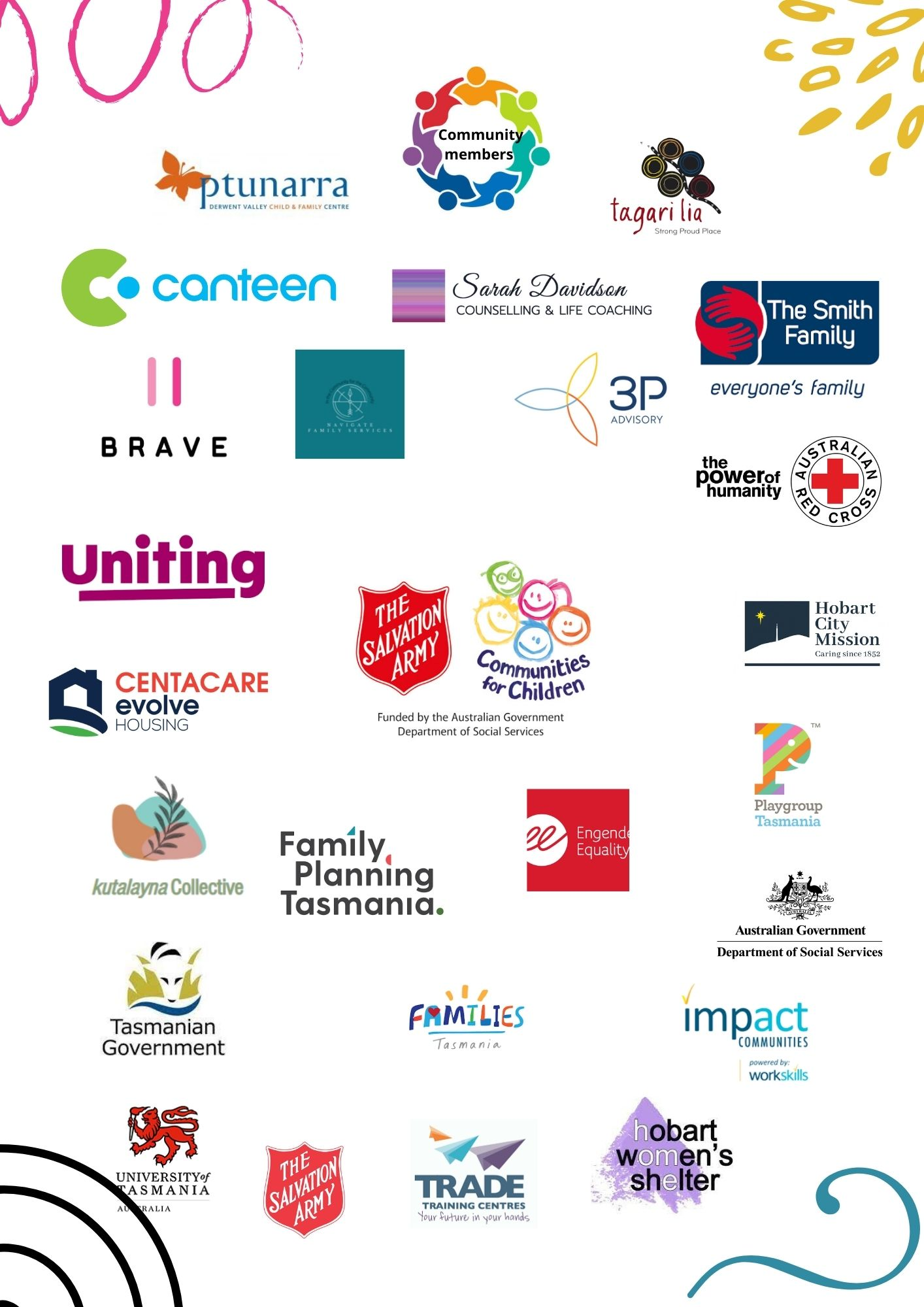

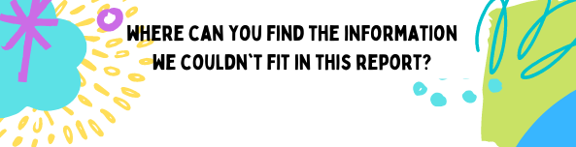

Communities for Children – SE Tas 2017-2019 Strategic Plan <https://www.salvationarmy.org.au/scribe/sites/tasmaniac4c/files/STRATEGIC_PLAN_2015-2019_FAMILY_SUPPORT_PROGRAM.pdf>

Communities for Children 2019 Review by Romy Winter and Ron Frey <https://www.salvationarmy.org.au/scribe/sites/tasmaniac4c/files/FINAL_FREY_AND_WINTER_REPORT_April_30_2019.pdf>

Communities for Children SE Tas Theory of Change 2022-2026 <https://www.salvationarmy.org.au/tasmaniac4c/>