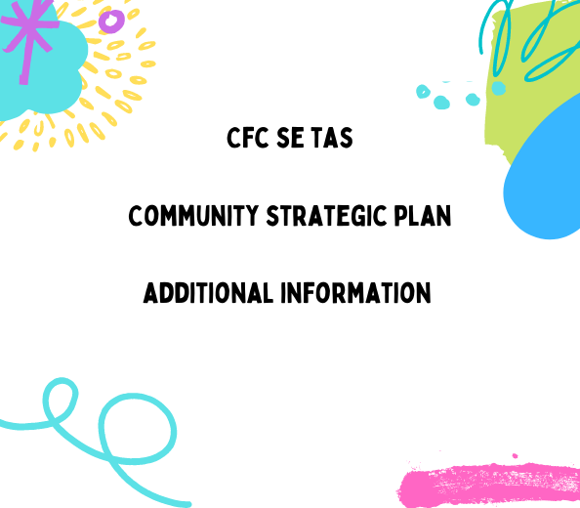

Communities for Children South-East Tasmania acknowledge and pay respect to the Tasmanian Aboriginal people as the traditional and original owners, and continuing custodians of this land on which we gather today and acknowledge Elders – past, present and emerging.
We acknowledge those who have passed before us and acknowledge Tasmanian Aboriginal people who are living and working in our Communities for Children activity areas, and we acknowledge that sovereignty has never been ceded.
We stand for a future that profoundly respects and acknowledges Aboriginal perspectives, culture, language and history. And a continued effort to fight for Aboriginal justice and rights paving the way for a strong future.

What we’ve been told | What we willdo | Who will we involve
Communities are sick of being asked what they want and not told what happens with that information | Our CfC program and Community Partners will be considerate when collecting information (and really think about what we need), and we will commit to feeding back what we do with the information to the communities.  We will commit to sharing our data gathered (de-identified) with our network and government partners – to avoid over consultation and open the doors to collaborations. | Communities for Children – SE TAS  CfC Community Partners  CfC Network Partners  Government Partners  Other organisations that operate in our communities
Communities don’t know what is on offer to support them. | Our CfC Program and Community Partners will actively share information through a variety of communications methods (see CfC Connect) to ensure service information is public, available and we share regularly.  We will ensure our contact details, and our partners contact details are on as many databases, and included where ever we can. | Communities for Children – SE TAS  CfC Community Partners  CfC Network Partners  Government Partners  Other organisations that operate in our communities
Fathers feel left out of program offerings | CfC FP and Community Partners will ensure programs are open, accessible and friendly. Where we can we will collaborate to make programs happen just for Fathers to ensure they can access capacity and skill building around the complicated role parents/carers play in our children’s lives. | Communities for Children – SE TAS  CfC Community Partners  CfC Network Partners  Government Partners  Other organisations that operate in our communities
Flexible hours – not every drama happens during business hours | We will work with our Community Partners and networks to create flexible working hours and outside business hour opportunities for families to get support.  We will work with other funding bodies to include options for after work hours, and weekend funding is available. | Communities for Children – SE TAS  CfC Community Partners  CfC Network Partners  Government Partners  Other organisations that operate in our communities
Drive in and drive out services just don’t work! | CfC FP has a strong belief in funding place based programs, that provide a safe, accessible, inclusive space for the community by the community. Our 2022-2023 have a variety of place based, and supported (networked in) mobile community program offerings.  CfC partners will work at encouraging other funded services to come and work in a place based/regular manner in our communities through collaborations and support to ‘connect in’ with the locals. | Communities for Children – SE TAS  CfC Community Partners  CfC Network Partners  Government Partners  Other organisations that operate in our communities
The workers change all the time! | This is a difficult one, with high burn out rates in our community sector.  CfC FP will work closely with our Community Partners to ensure sustainability plans are in place, and expectations are managed. Our changing model means there might be people changes, and we want that to happen in a way that does the least amount of damage.  We believe our commitment to place based funding will assist in keeping our key CfC presence stable, and in fact, growing in our 4 communities.  CfC also has a commitment to real relationships and collaborations, skill sharing and training, and we hope by building our capacity, we can manage burn out, career changes, and people changes. | Communities for Children – SE TAS  CfC Community Partners  CfC Network Partners  Government Partners  Other organisations that operate in our communities
Everyone thinks our area is full of bad things happening. | CfC has actively been a part of working to change the narrative around our areas for decades. We see the opportunities, the strengths and our people for the champions they are.  We encourage real conversations, celebrations, and constructive social, media and political conversations around our areas, and we actively promote the wins, the people and the stories. | Communities for Children – SE TAS  CfC Community Partners  CfC Network Partners  Government Partners  Other organisations that operate in our communities

The LG area of Brighton sits a mere 20 minute drive out of the centre of Hobart. The area is going through a rapid change of pace, with a range of community housing being built in the area, and properties hitting the market selling for $500 000.
With views to die for, this area has a reputation of being tough, and dangerous. The families, the stories, the community is very strong, connected, and sometimes this closeness plays a role in deep rifts in the community.
The area can be considered over serviced, with agencies getting funding to address the ‘huge’ issues, though, agency presence on the ground is haphazard and limited. This overservicing/underservicing makes accessing services very confusing, and has built a greater divide in people getting the support they need.
The Brighton Council has recently had a change in leadership, however, the areas of Bridgewater, Gagebrook and Herdsman Cove, housing areas, have felt ignored and isolated for decades. Connections and partnerships are certainly on the rise between Council and MONA/24 Carrots, and we hope that sees a change in local government support in the area.
The area has a strong emerging Aboriginal population, and strong Aboriginal services in the Child and Family Centre tagari lia, the Kutalayna Collective Table (collective impact project focussing on Aboriginal children 0-5) and Connected Beginnings Project.
24 Carrots, a MONA project, is doing some ground breaking work in the schools around community gardens, pride, cooking and creative activities. This is shaping the look and feel of the area, and opening the students eyes to endless possibilities.
Bridgewater has some of the highest rates of smoking and obesity in Australia, and some of the toughest breaks around COVD-19 and the quarantine escapee in mid 2021. We are conscious those are areas we can all support through our face to face services, as well as working on spreading information online.
There are numerous schools in the area, and some have participated in Rumbles Quest, an engaging app based wellbeing tool for students in grade 1 – 3, and those results have put the students in the lowest levels in Australia.
Primary students, when they have a choice, head into Hobart for high school, rather than go to Jordan River Learning Federation Senior School. There is new energy in the high school, and those changes might be the energy to change the pathways, but it can’t be overlooked the high school graduated 1 student in 2020, which is concerning.
Our consultation in the area has revealed the following gaps:
- Activities for school aged children
- Gaps in opportunities/jobs for the young people
- Parenting courses/support
- Families knowing what was available
- Services knowing what was available
- Schools being ‘closed shops’ so services/parents feel they can’t connect in to support the work that is being done
- Gaps in fathering courses and support
- Changes in the services, people working in the community, so it’s hard to keep up
- Lack of access to doctors and medical professional

Derwent Valley
The Derwent Valley is another rapidly growing area, with a huge increase in community housing, and sky rocketing house prices in the region, with little to no rental availability.
Families are moving to rent or buy in the more remote areas, which introduces a new range of issues around digital and social connection, community support, and access if transport is an issue.
Schools in New Norfolk are reporting drops in numbers as high as 100 students in 2021, impacted by the difficultly getting affordable housing near by, while schools in the outer areas are getting an increase. Families are also connecting more to home schooling to work around their geographical distance to get to tow.

New Norfolk, while it’s growing and has some more boutique shops and eateries appearing, still lacks local employment options, so people need to travel for work. Public transport isn’t reliable or affordable.
New Norfolk has a ptunarra, the Child and Family Centre, and a number of long term community support organisations, however, a lot of services drive in and drive out, and having limited capacity.
The children and families in the region report feeling quite scared of drug dealers and loud hooning drivers, though anecdotally local police tell us the figures are reducing. Certainly crime feels like it’s increasing according to the social media groups, and that is causing distress.
Gaps we know about:
- Accessing a doctor or medical professional is almost impossible
- Activities for children and young people
- Job opportunities are limited for families/young people
- Community doesn’t know what services are available
- Services don’t know what services are available to do referral
- High needs for emergency relief and support
- Increasing homelessness
- School readiness/healthy lunches are in decline
The Southern Midlands is an strong, independent area, with an engaged Council and a strong network of support. They are intrinsically connected as an established community, however, with the prices in housing rising, they’ve had an influx of new community members to the region.
They report feeling forgotten, and feeling quite isolated, and having very limited access to services. Similar to our other CfC areas, if you do a search for support agencies online there are a list of agencies that offer support, however, in practice many of them rarely come to the area, and offer telephone and online assistance. This doesn’t work for a community who needs to see, trust and connect with service providers.
Families with transport have much better access to activities than those that don’t. Events and activities held outside the townships mean missing out if you can’t get there.
The area has a growing network of small boutique businesses, bringing new jobs to the region, just not in the numbers the area needs. This energy is fabulous to see, the challenge will be taking everyone from the community along with the changes. The town leaders are also aging, which leaves gaps, weariness and worry about the future.
Rural Alive and Well (RAW) has set up in Oatlands, which is growing available support for mental health, and the Community Centre has rooms available for groups and services to use. There is also a vibrant community centre, great schools, a growing connection to the tourism market for different jobs coming to the community.
Internet connectivity is an issue for rural families, and the cost of getting a satellite connection often leaves families in a NBN black hole. This impacts on education, work, digital literacy and schools/services contacting families.
Gaps we know about:
- Accessing a doctor or medical professional is almost impossible
- Activities for children and young people
- Job opportunities are limited for families/young people
- Community doesn’t know what services are available
- Services don’t know what services are available to do referral
- High needs for emergency relief and support
- School readiness/healthy lunches are in decline

The Central Highlands is a strong, rural community. The schools in the area range in size, but Ouse District School has 13 students in 2022. Department of Education has confirmed the school will stay while families are in the area, but a small school comes with it’s own intracies and impacts on learning.

During COVID services identified homeschooled students that hadn’t popped on to our radar until they reached out for support during lockdown.

The area has a well established Community Health Centre, that has historically provided a huge range of services and support to the families. The workers in the service have high trust levels and connections with the community, and they welcome external people to assist with program delivery with open arms.

The community takes a while to build trust, and with such a small group of families it can be a real challenge to run successful programs in the area. As families live rurally, they are quite often very busy with farm life, so connecting them in to regular offerings just doesn’t work, and our partners have to work flexibly in order to offer supports. In some cases, that’s proven too hard, and services have just disappeared.
School students tell us there is nothing to do, and they feel like they just don’t have the same opportuniies as kids in the city.

Gaps we know about:
- Digital connection issues
- Medical services (though at writing this, this seems to have settled a little bit)
- Transport issues – especially with the lack of public transport and high fuel prices
- Food is expensive – with less options for buying fresh items
- Literacy issues (for whole families)
- Isolation
- Lack of things to do

National Agreement on Closing the Gap
          - Closing the Gap Targets and Outcomes

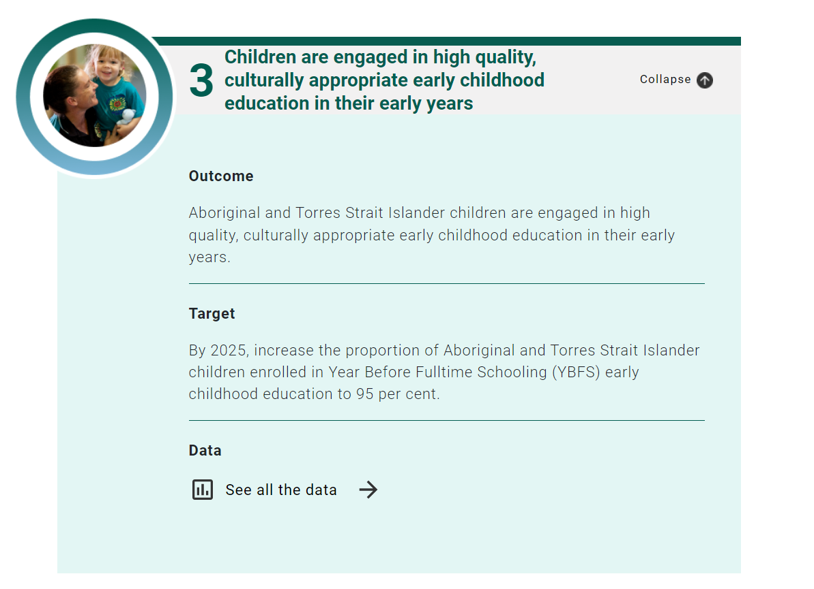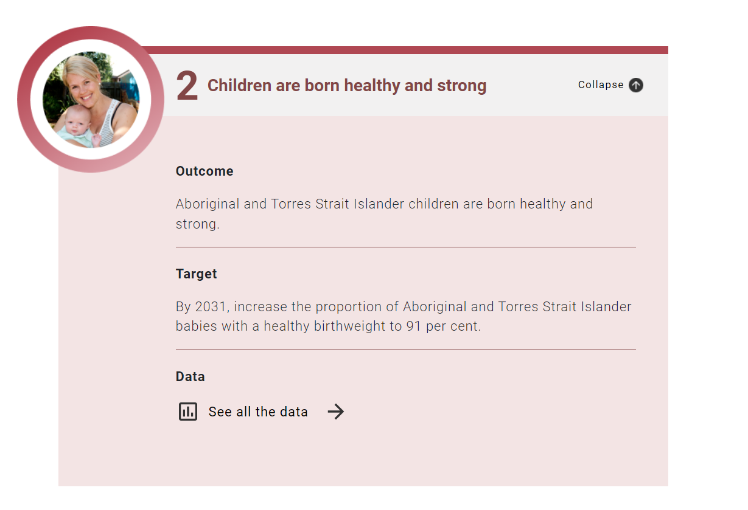
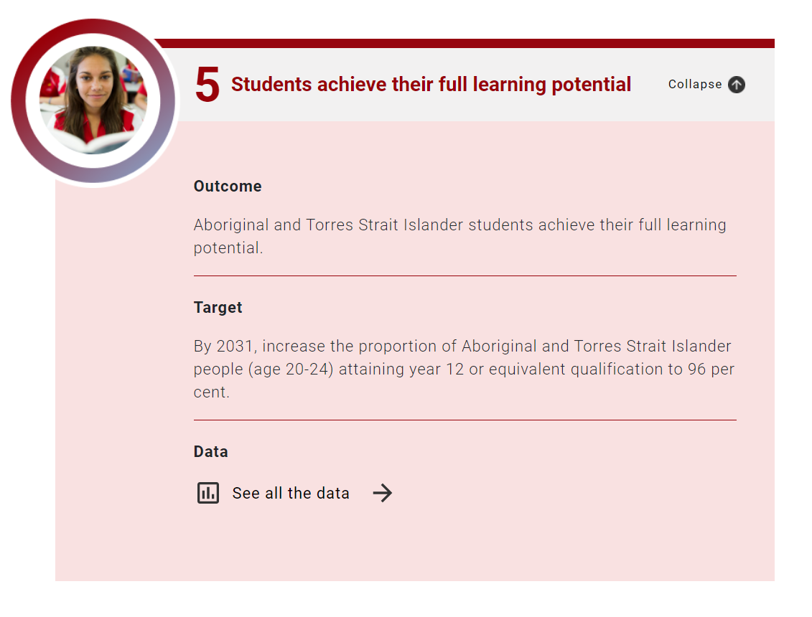
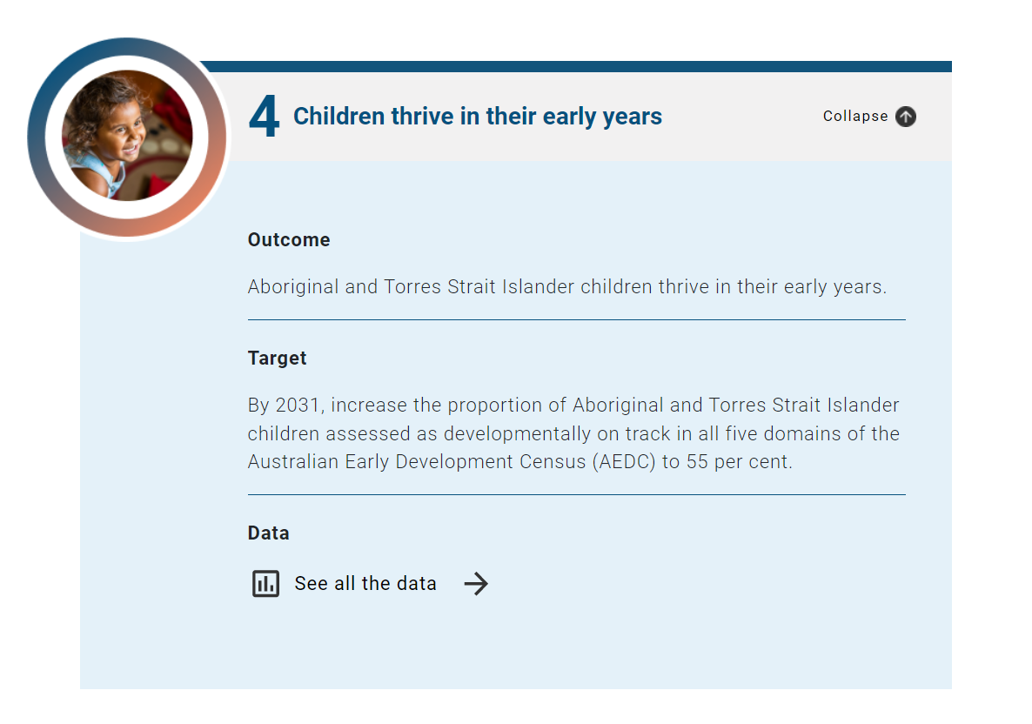

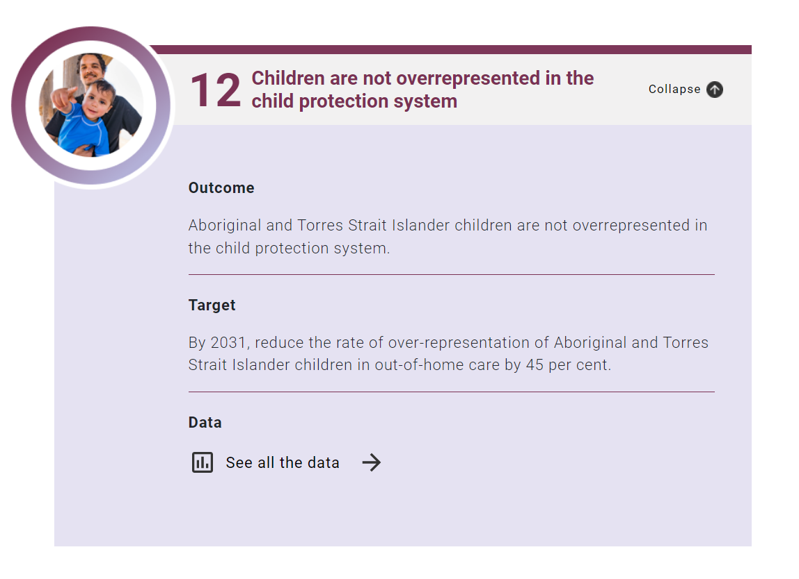
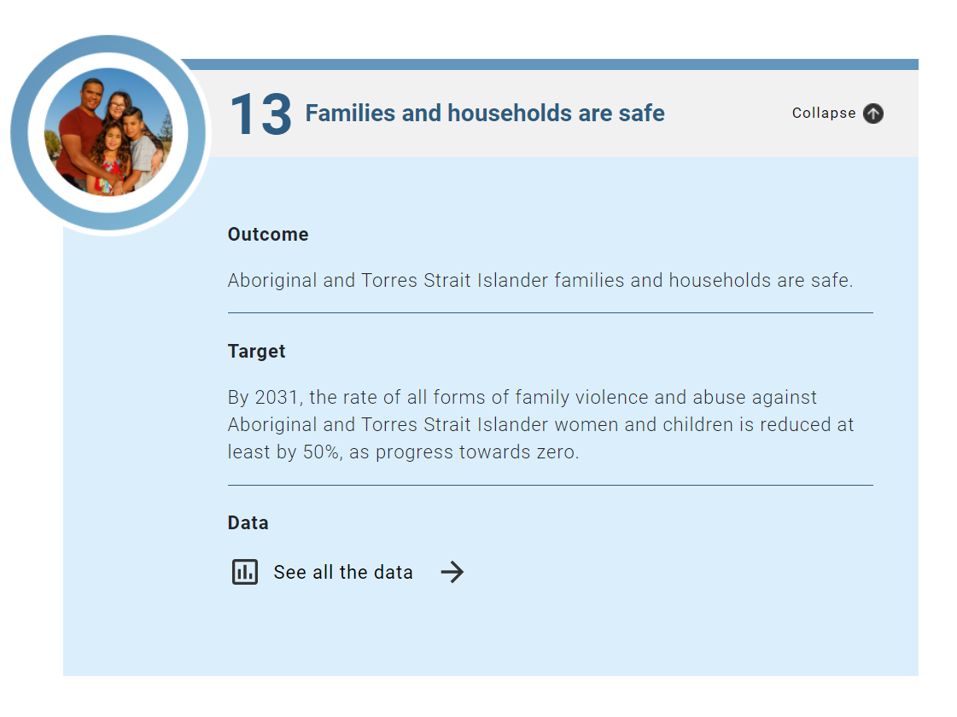
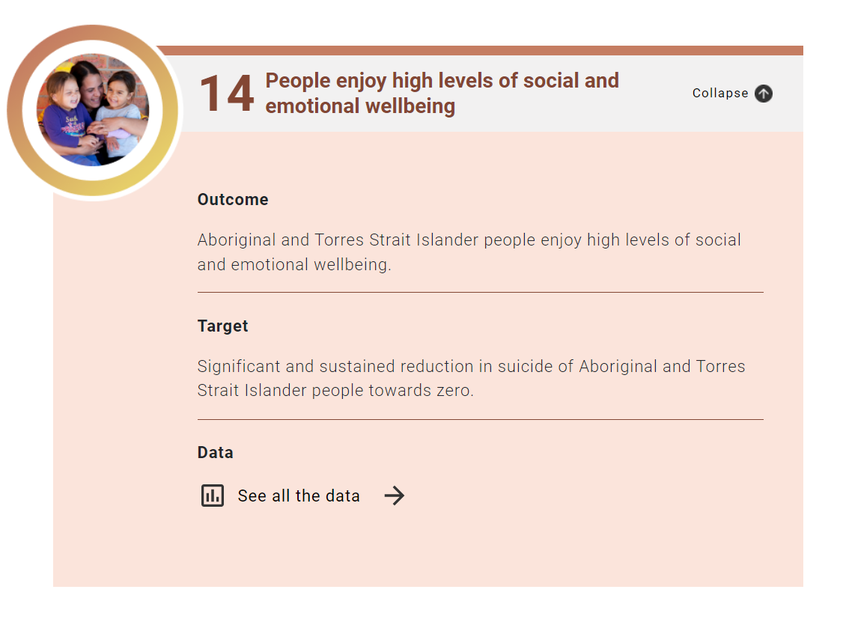
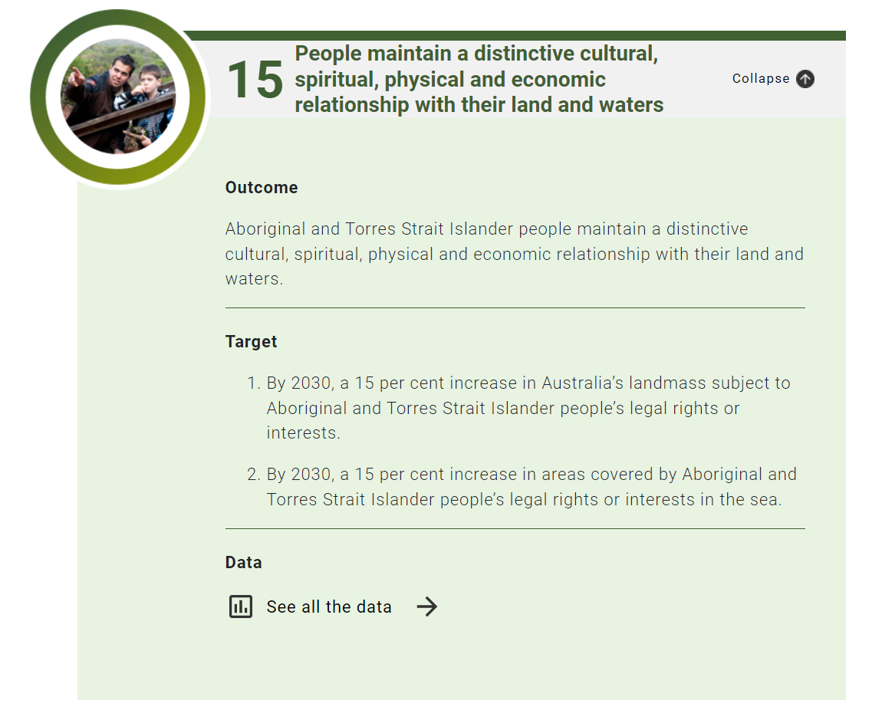

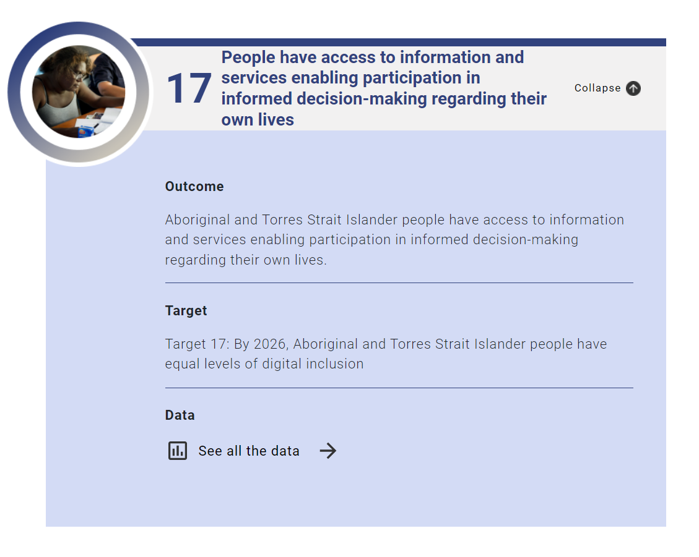

National Framework for Protecting Australia's Children

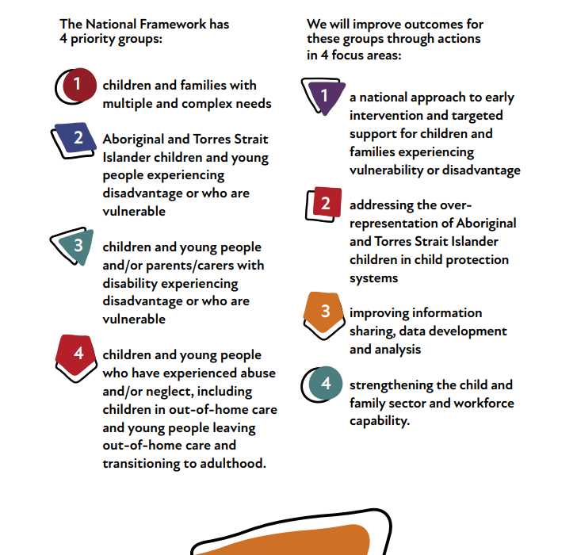
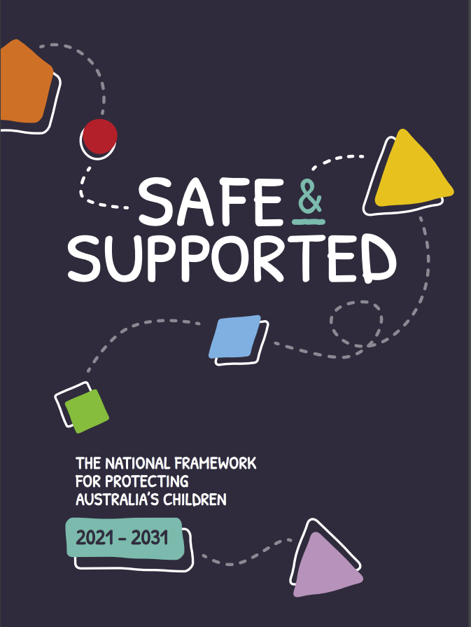

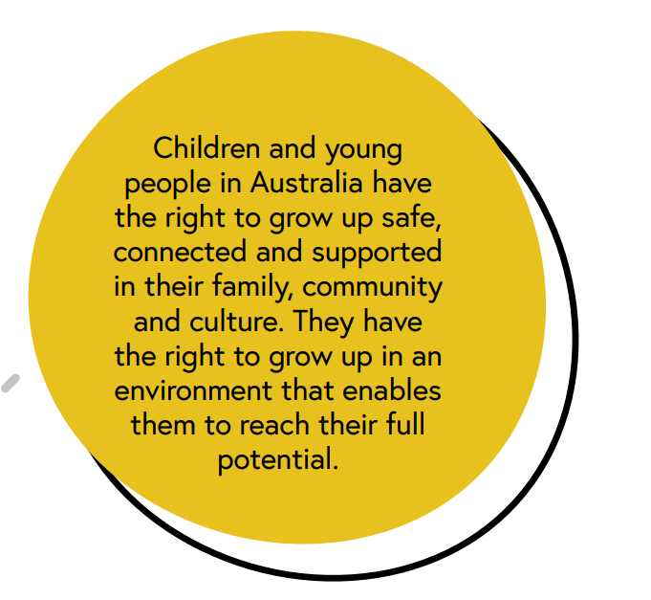
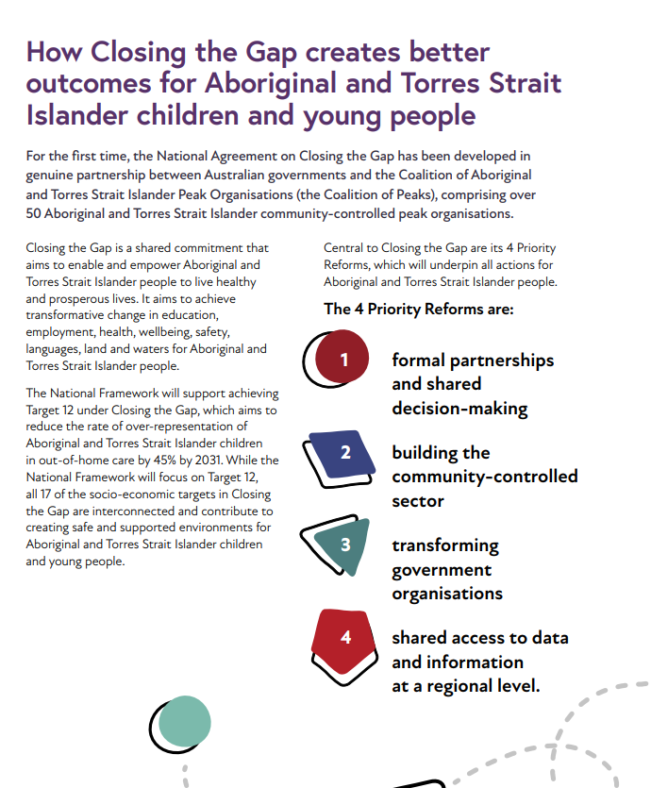

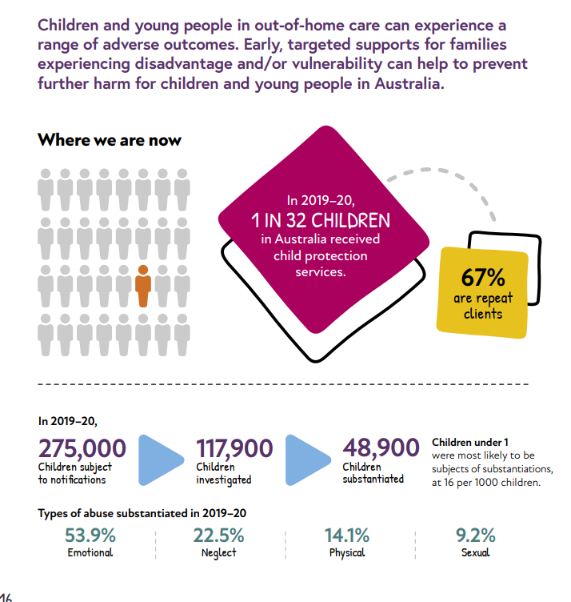
National Plan to Reduce Violence against Women and Their Children 2010-2022.
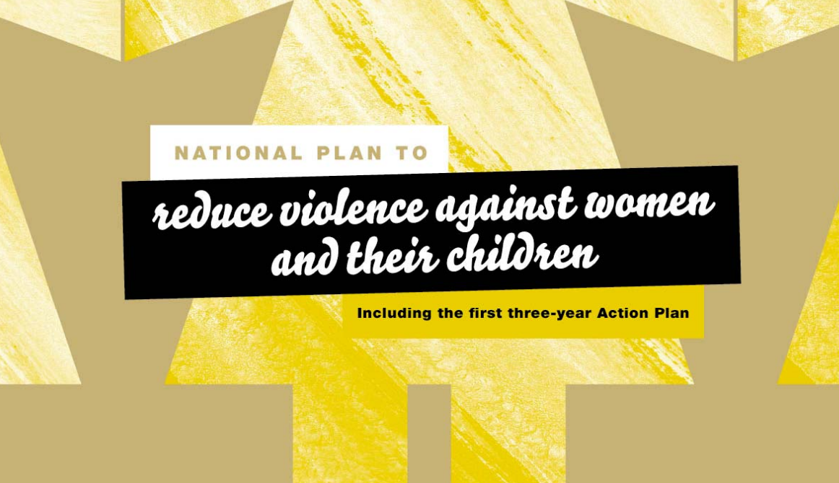
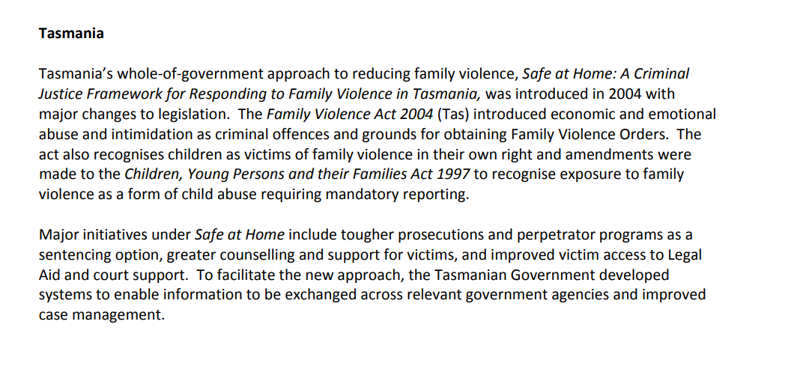

Our primary focus is on children aged 0-12 years and their families but sometimes we include children/teens up to age 18 years.
Over the years we’ve also narrowed our program focus to the 6-12 age group, as Tasmania has an excellent range of pre school supports in place which include:
- Child and family centres (tagari lia and ptunarra) (prebirth to 5 years, tagari lia has a focus on supporting Aboriginal families)
- Child Health and Parenting Services (CHAPS) (pre birth – 5 years)
- HIPPY Brighton (4 year olds)
- Working Together (3 year olds)
- Playgroup Tasmania
- Connected Beginnings (Aboriginal families with children pre birth to 5 – now with the Tasmanian Aboriginal Centre)
- B4 Early Years Coalition – a professional network working towards improving outcomes around the first 1000 days
Strategies
- It takes a Tasmanian village – Tasmanian child and youth strategy
- National Children’s Mental Health and Wellbeing Strategy
- The First 1000 Days
This support and program wrap around tends to get more complicated during primary school, when the primary focus moves to education, and the primary form of contact is through the schools.
Accordingly, CfC has a strong relationship with the schools through:
- Staying in contact with key school leaders (principals)
- Working alongside the School Nurse and Social Workers
- Supporting the school associations – either by attending meetings or resourcing
- Our small grants program is open to school associations to apply for to address any gaps/make things happen in the school environment
- Funding Rumbles Quest for prep – grade 3, to provide an accurate whole of school snapshot for planning (Department of Education runs a grade 4-12 wellbeing process annually)
We work with families and carers in our regions that have children in their world. We work on a systemic level, a community level and a person-to-person level. Our programs are as diverse as our families, and at all times we listen, learn and innovate to respond in way that is appropriate and individual.
CfC has a gentle/soft entry practice base, so we gather only the information required to support and work with families, and to track their outcomes using the SCORE framework.
Our Community Partners work directly with families as a whole, and only with children when the parents/carers are informed and have given permission.
Our Community Partners are proud to provide inclusive, accessible services. They advertise widely (where appropriate) and they welcome families in to their services.
CfC’s work hard to provide flexible, culturally sensitive and accessible service delivery models and practices that ensure accessibility to people who face a real or perceived barrier to receiving assistance, and have in place strategies to achieve this unless otherwise exempted by legislation. In fact, as we move forward, our relationship accountability practices will include regular ‘check in’s with our families through our Community Partners to ensure no opportunity to connect is missed.
You’ll notice as you move through this document that this funding round does include some options for the 0-5 age groups, and that has come about as families have identified the lockdowns and isolation hasn’t offered them the opportunities to connect in with services or join in easily to the regular program offerings.
In 2022 through our partnerships with Families Tasmania and Playgroup Tasmania, we’ll be offering soft entry programs to support parent child bonds, linkages to other services, connection with other families. We love being in this space, and seeing the huge changes families make when supported through music, play and great people.
We use these documents to guide our overall practises:
- Families and Children Activity Administrative Approval Requirements (https://www.dss.gov.au/our-responsibilities/families-and-children/programs-services/family-support-program/families-and-children-activity-administrative-approval-requirements)
- Access and Equity Policy (https://www.communitygrants.gov.au/information-recipients/access-and-equity-policy)
- Families and Children Access Strategy Guidelines (https://www.dss.gov.au/our-responsibilities/families-and-children/programs-services/family-support-program/families-and-children-access-strategy-guidelines)

At Communities for Children SE we balance our work using Evidence Based Program delivery, with community programs and encourage our Community Partners to move through the AIFS process to list emerging programs on the Evidence Base list.
We strive to meet, and exceed, the requirements of 50% Evidence Based Programs funded by our CfC, and this is made much easier with our strong partnerships with our communities and Community Partners.
We evaluate – not just using the ‘minimum requirements’ but through data, SCORE, stories, feedback forms, conversations.
CfC SE Tas also encourages any of our pilot programs that show transferability to other areas to consider working with AIFS to go through the steps to get listed as an Evidence Based Program. This builds sustainability, shares community trialled successes, and encourages our Community Partners to think bigger.
The Evidence Based Programs our CfC can consider can be found here: https://apps.aifs.gov.au/cfca/guidebook/
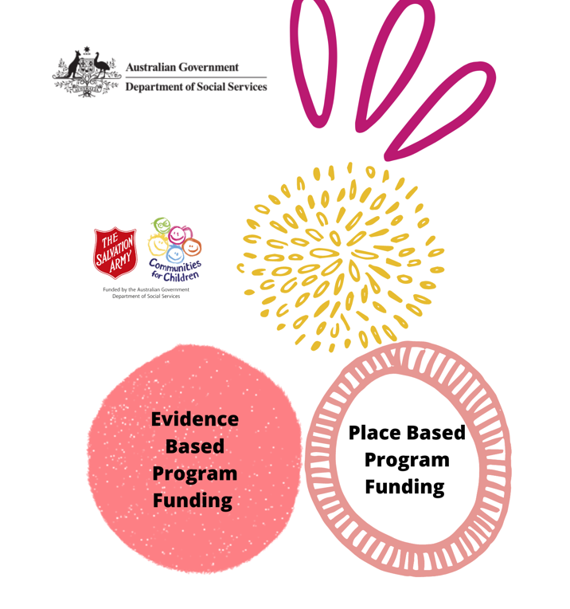

At the time of writing this document our CfC has actively used the following programs from the list:

1-2-3 Magic and Emotion Coaching
Bringing Up Great Kids
Circle of Security (CoS)
Cool Kids
DRUMBEAT (Discovering Relationships Using Music, Beliefs, Emotions, Attitudes and Thoughts)
FAST (Families and Schools Together)
Fun FRIENDS, FRIENDS for Life and My FRIENDS Youth
Incredible Years
Journey of Hope
Parent-Child Mother Goose (P-CMG)
Parent Effectiveness Training (PET)
Parents Under Pressure (PuP)
Seasons for Growth
Secret Agent Society
Sing&Grow
smalltalk
Tuning in to Kids
Tuning in to Teens
What Were We Thinking! (WWWT)

As a whole, Tasmanian communities are changing, some faster than others.
What’s the change | What’s our role | Who else | Outcomes?
More people moving to areas due to housing shortages/cost of living hikes | To connect, support and engage new members to our communities. | CfC FP  CfC Community Partners  CfC Networks | Reduction in feelings of isolation  Increase in support to families  Rise in feeling connected
Social isolation and an increase in loneliness (covid impacts) | To connect, support and engage family members where we can | CfC FP  CfC Community Partners  CfC Networks  Local Councils | Reduction in feelings of isolation  Increase in support to families  Rise in feeling connected
Changing community dynamics | To connect, support and engage families in their community – support new agencies coming to our communities by linking them in and sharing their information. | CfC FP  CfC Community Partners  CfC Networks  Local Councils | Services delivering services that align, and are needed by, the changing community members.
Cost of living hikes | To connect, support and engage family members where we can.  To try new things, and connect with services that provide ER to ensure there is enough supply for everyone | CfC FP  CfC Community Partners  CfC Networks  Local Councils | Community members trying new ways of spending their money.  New Initiatives started that support families cope with increased cost of living  Services responding and providing services that build dignity and self motivation/choices,

Risk | Plan | Who | Outcome
Communities are sick of being consulted and not hearing back | Work collbaratively with other services to ensure information is gathered respectuflly, shared where appropriate, and community members get feedback about what their info was used for | CfC FP  CfC Community Partners  CfC Networks  Local Councils | People engaging and feeling engaged with the process and outcomes.  Services saving their resources doing too many surveys, and instaed they can focus on making things happen the community wants.
Tired sector -it’s been a long few years | To engage, train, inspire our community sector throuigh:  - Interesting training opporunities  - Celebrations of wins and milestones  - Saying thank you  - Acknowledging and encouraing conversations/relationships that are supportive | CfC FP  CfC Community Partners  CfC Networks  Local Councils | Connected workers who know who to talk to, when to rest, have ideas on trying new things, have the time to think, plan and process
Regional stigma – 7030 carries a world of hate from the general Tasmanian community | A communication project as a coordinated response that:  - Shares good news stories  - Highlights the community leaders  - Celebrates the wins in the community  - Supports the ‘bones’ of our community – schools, local government etc to thrive  - Shares good news stories with the wider media/social media to get the word out there | CfC FP  CfC Community Partners  CfC Networks  Local Councils  Community members  Business | A building of community pride and celebrations that will loudly cover the negiative historical public perceptions of the community.
Services not moving with the times – delivering old things in old ways | As a collective we will work to:  - Embrace change  - Learn new things  - Offer to skill share  - Arrange training and learning experiences  - Try new ways of doing things  - Use our community members VOICES to lead the building and delivery of programs – so we are delivering what they want, where they want.  - Name it up – talk about how things are done and how we could do  - Welcome feedback  - Challenge our own decision making, and check our goals and values | CfC FP  CfC Community Partners  CfC Networks  Local Councils  Community members  Business | Services moving with the times and communitiy changes, trying new things, learning along the way.  Outcomes becoming more positive and sustainable – as the work is aligned with what the community wants and needs.
Services being funded but not delivering in our regions leaving gaps for our community members – building over service fatigue for services who are picking up the slack | A collective effort to:  - Support and encourage services to come to our areas to deliver – inlcuding supporting finding a space to work from regularly and offering strong referal pathways/warm handovers  - Gathering the data around unmet needs/over delivery to provide to funding bodies/funded services to show a need in the area for face to face delivery | CfC FP  CfC Community Partners  CfC Networks  Local Councils  Community members  Business | Increase in diversity of service provision in our areas.  Less burnout for workers/agencies who are working out of scope to support our families  More understanding for funding bodies on the current needs in our changing communities
Changing community dynamics and demographics | A collective effort to:  - Notice the changes in our areas  - Asking our new community members what they want and need from us – and working collectively to make this happen.  - Call in the ‘experts’ and supports to ensure we are adapting our services to meet the changing needs of our community (learning by listening – learning by sharing)  - Gathering data and sharing observations and new needs to adjust funding/programs and supports in the areas to reflect the changes in our people  - A collective goal of sharing, learning, curious questions to value and celebrate the changes in our community people and richness. | CfC FP  CfC Community Partners  CfC Networks  Local Councils  Community members  Business

CfC at its heart is a working collective impact project.
Our CfC FP team plays the backbone role, our Committee is the Leadership Table, and our Action Groups are our Community Partners, our networks and our sector.
While it’s a complex way of working, the opportunity to collaborate for change, driven by the voices of our community, it’s a journey we are pleased to be on.
Collective Impact is a collaboration framework that engages across sectors and groups who share a common interest to address a complex social issue, in a given community. The concept was first articulated in by John Kania and Mark Kramer in the Stanford Social Innovation Review in 2011. That article outlines five key elements in a collective impact initiative:
- A common social agenda
- A shared measurement framework
- A shared plan of action for mutually reinforcing activities
- Open communication fostering genuine collaboration
- A backbone organisation with the skills and resources to keep everyone on track.
While a relatively simple framework, the execution of these five elements takes considerable time, skill, and resources.
https://socialoutcomes.com.au/toolkit/collective-impact/
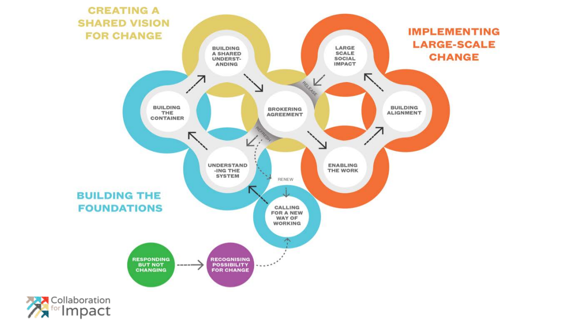

https://collaborationforimpact.com/wp-content/uploads/2018/11/Collaborative-Change-Cycle-Nov-2017-low-res.pdf
We also implement Asset Based Community Development strategies in our work – to ensure we are building and solidifying what we have in asset sense – and celebrating our community resilience all the way through this journey.
https://s3-ap-southeast-2.amazonaws.com/boifiles/wp-content/uploads/2017/ABCD+Overview+Cunningham+Mathie.pdf
This work is ongoing, and we’ll add to our responses, wins, opportunities and losses as we move along.

Innovation does not happen in a vacuum. To bring about lasting, population-level improvements for children facing adversity, we must foster a collective movement. When leaders and change agents align their agendas, networks, and resources in support of a shared goal, they have the power to achieve larger and more sustainable breakthroughs for children and families.
Collective Change: Learning and Leadership in Early Childhood (harvard.edu)

At CfC SE Tas our innovations have come out of conversations, creative thinking, sharing and trying new things.
We have tried:
- Creating the Kid’s Think Tank to decide on our small grants.
- Making up ‘if u aren’t ok cards (that went national within The Salvation Army!!)
- Making up anti poverty week info cards
- Started an enews that reaches out to everyone we can
- Offered training – and created training – that fits what our community and networks are wanting to learn about
- We’ve made fun things happen – including trying to bring back the elastics game for kids!
- Participated and created COVID19 community response groups
- Written books! So many books! On things that matter to our kids https://www.salvationarmy.org.au/tasmaniac4c/publications/
- Recreated our website so it’s a hub of valuable information and support for families
- Upped our social media presence – to connect with families where they are (and we still print and put up posters!!)
- Have done Pop Up days – to connect with families who don’t, or can’t, get to regular program offerings

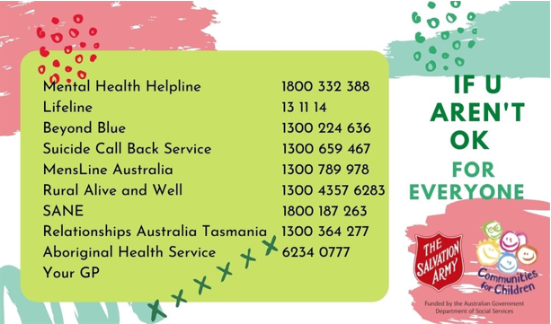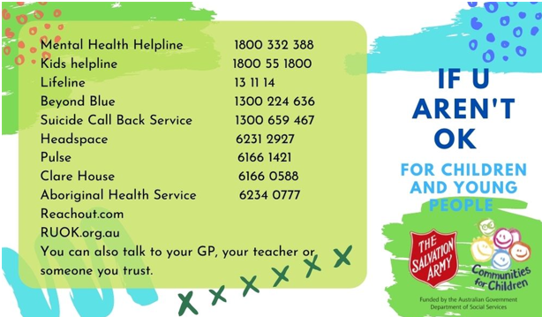
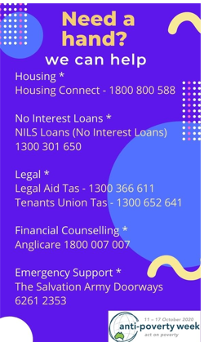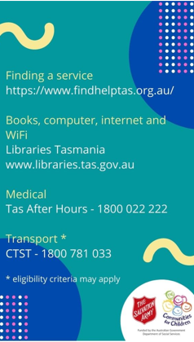

CfC FP is committed to participating wherever we can in processes and programs that add value to our program delivery.
This includes right now working with:
- AIFS Expert Panel
- FRSA Conference planning
- TSA CfC Network
- CfC Tasmania networks
- Exploring the option to support ChangeFEST
- Exploring the option to support Anglicare Tas in their annual CfC conference

Memberships change as our program changes, and as oppotuniies arise.

