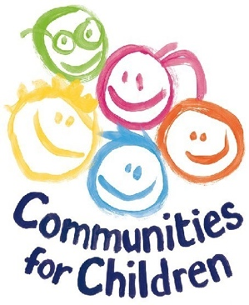
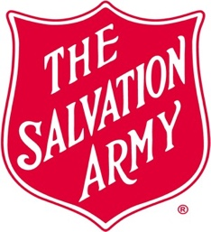
COMMUNITIES FOR CHILDREN

South-East Tasmania

Small Grant Application

2023-2024 - Guidelines

Communities for Children Small Grant program is now open!!!
Every year The Salvation Army, Communities for Children SE Tasmania (CfC) provides small grant funding to deliver activities and programs to our areas of Southern Midlands, Brighton, Derwent Valley and Central Highlands.
In the past the small grants were decided by the CfC Funding Panel, but now projects that meet The Salvation Army (TSA) and DSS requirements will be assessed by the CfC Kids Think Tank, together with a team of committed mentors.
As a program, CfC is committed to listening, hearing and promoting the voices of our families, and our children, and this is our way of ensuring the small grant funding goes to where it needs to go – with the endorsement of our community’s savvy students!
In 2023 we’re making the program bigger and better.

Grant Guidelines
Grants are available for amounts between $500 and $10,000 and are open to local organisations to initiate or develop activities that improve parenting, safety and resilience, build community capacity and the health and wellbeing of families with children aged 0-12 years.
Eligibility
Applications for a CfC Small Grant will need to demonstrate that the request for support contributes to our focus areas/program ideas:
- resilience
- aspirations
- increase safety in communities
- school transitions (into primary school, out of primary school).

Who Makes the Funding Decisions?
Projects that meet The Salvation Army (TSA) and DSS requirements will be assessed by the CfC Kids Think Tank, together with a team of committed mentors.
Small grant applicants will be asked to free up some time to discuss their grant with the CfC Kids’ Think Tank, which will be held in October. You can either present in person, online, or with a short video. Even you are able to attend on the day, we suggest a short video that might better demonstrate or show your idea to the team.
The Think Tank will have suggestions and tweaks, so please be ready to adjust accordingly!
Writing Tips
- Please complete ALL the sections of the form.
- If you are unsure what we want, please contact us to talk about your activity.
- Please write your grant with the students (grade 4, 5, 6 and 7) from your area in mind.
- Avoid acronyms and take the time to really explain the why, who and outcomes of your activity – the kids are really interested in all the details.
- Consider putting your answers into the Hemingway App (https://hemingwayapp.com) to see what Grade level you are writing. You’re aiming for Grade 4 or 5 at for this audience.
Our Communities for Children Funding Committee and CfC Team will be providing the administration support to ensure applications are in line with the grant and DSS funding criteria.

Exclusions
Applications are ineligible if the request for funding support is for any of the following:
- Scholarships or Bursaries
- Commonwealth, State government funded agencies (local government may be included with the support of our funding body)
- Fundraising drives
- Duplication of existing programs or projects
- Upgrade or improve buildings or assets
- Individuals with a business benefit (unless private community service focussed business)
- Activities that are the responsibility of other funding programs.
Note: Applicants must have adequate public liability insurance for their proposed activity.
Applicants who are awarded a grant will be required to enter into a service agreement with The Salvation Army. Compliance with the terms and conditions outlined in the agreement will be required.
Should circumstances change and other funding is sourced for the same project, The Salvation Army must be notified, and a variation submitted for approval by the Communities for Children Funding Committee. In some cases, the grant payment may need to be returned.
For more information on the Communities for Children program please visit our website:
www.cfctas.org.au

APPLICATIONS CLOSE 5.00pm Thursday 31st August 2023 and the
Kid’s Think Tank will be meeting on
13th October 2023 to make decisions.

