START TODAY AGAIN
Fathers healing relationships after family violence
DVD’s & YouTubes Resources

 |  | Multi Media
Aboriginal clip  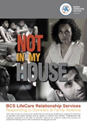 | 1 | Kathy, Mark and the children at Home | Video  https://baptistcare.org.au/assets/Uploads/D00442-NIMH-OrderForm2.pdf
Aboriginal clip | 1.2 | Kathy, Mark and the children at the Park | Video  https://baptistcare.org.au/assets/Uploads/D00442-NIMH-OrderForm2.pdf
Aust couple | 1.3 | Belinda and Steve | Video  https://baptistcare.org.au/assets/Uploads/D00442-NIMH-OrderForm2.pdf
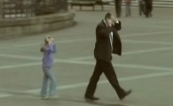 | 2 | Children see children do | https://www.youtube.com/watch?v=KHi2dxSf9hw
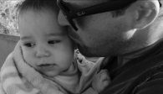 | 3 | Dads try the Still Face experiment | https://www.youtube.com/watch?v=_Lh5-dzf5do
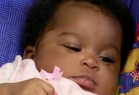 | 4 | Mothers Still Face Experiment | https://www.youtube.com/watch?v=apzXGEbZht0
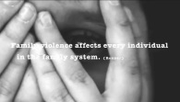 | 5 | Domestic violence impacts and children | https://www.youtube.com/watch?v=H2zy5DBh_Q0
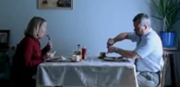 | 6 | Domestic Violence Commercial | https://www.youtube.com/watch?v=c96dktDFgyk
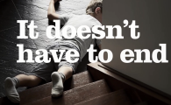 | 7 | Domestic violence impacts on children | https://www.youtube.com/watch?v=o4phNGhl6LE
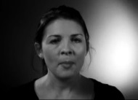 | 8 | Escape – A Domestic Violence Short Film – (including Children are victims too) | https://www.youtube.com/watch?v=egWFLkd2KP4
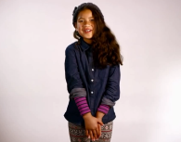 | 9 | It’s time to act on our watch | https://www.youtube.com/watch?v=tB7Pkcue9Rk
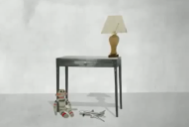 | 11 | Monsters in the closet | https://www.youtube.com/watch?v=LbRba9XHKKw
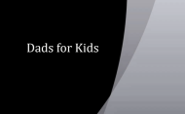 | 12 | Dads for Kids mp4 | Video
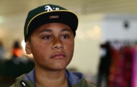 | 13 | Slap Her | https://www.youtube.com/watch?v=f6CDvSDkeAM
 | 14 | The effects of domestic violence on children | https://www.youtube.com/watch?v=GXZ7ubFoV1I
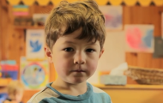 | 5 | The Mask You Live In | https://www.youtube.com/watch?v=PwC5d80h5HI
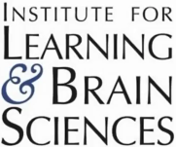 | 16 | Toddlers regulate their behaviour | https://www.youtube.com/watch?v=7FC4qRD1vn8
 |  | If I Could Start Today Again – Paul Kelly | https://www.youtube.com/watch?v=tb9nrAvGPaI
 |  | They Thought I was Asleep | https://www.youtube.com/watch?v=wYzSePqxoRI

