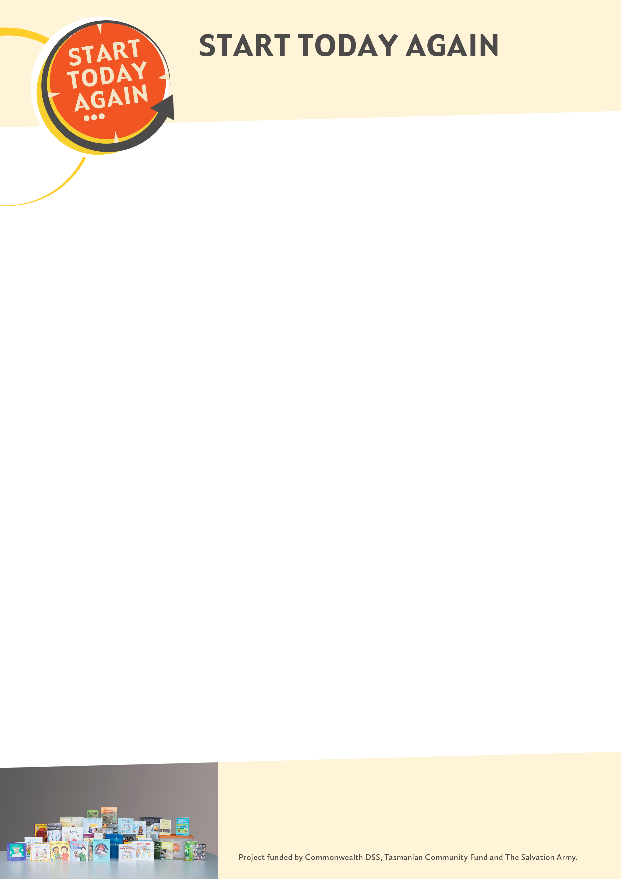

Fathers healing relationships after family violence

KIT ORDER FORM


ACCOUNT TO:
Organisation:………………………………………… Date…………………….
Contact person: ………………………………………Position: …………………………………
Address: ……………………………………………………………………………………………………
Suburb: …………………………..…State: ……….………. Post code: ……………
Telephone …………………………………Mobile: ………..…………………………
Email address:……………………………………………………………………………
Qty | Title | Total
 | START TODAY AGAIN Resource Kit $550 (plus gst) | $605.00 (including GST)
Includes:
- ‘Increasing Men’s Awareness of the effects on children exposed to domestic or family violence’, Dr Peter Lucas, UTAS, 2016
- START TODAY AGAIN Resource Kit Manual
- 35 resources: books, CD, DVD, activity books, YouTube film clip summary
- The SPONGE film clip on USB pen and posters
- Set of Duluth Wheels: Adult, children, TEEN, Muslim, CALD
 | Postage (within Australia) $POA per kit | $
 | Additional copies of report – ‘Increasing Men’s Awareness of the effects on children exposed to domestic or family violence, Dr Peter Lucas, UTAS 2016 $15.00 each
 | Additional brochures: small fold up .65c ea. Purple ‘seeing, feeling violence’ .25c each
 | Additional Posters 50c each, Not in my House DVD $10 each USB Pen with SPONGE clips and research reports $10 each
 | Duluth and other Wheels 50c each
 | TOTAL | $

As a result of the Safe from the Start action research study, a kit of therapeutic resources was developed for use by family violence services, child protection staff, counsellors, family and children’s services workers as well as parents with young children who have witnessed or been exposed to family violence, abuse or trauma, including recommendations on methods of best practice when working with children from these circumstances. A Safe from the Start training program was developed and conducted in all Australian states. SFTS won a National Crime & Violence Prevention Award in 2011.

The Train the Trainer program enables key staff to conduct SFTS training sessions in their own services and the wider community and covers:
- Evidence based research informing the Safe from the Start project
- The study findings regarding the effect of children who are exposed to family violence.
- What is family violence, therapeutic play and contents of the Resource Kit
- Resources ‘seeing, hearing and felling violence changes the way your child’s brain grows’
Each participant will receive a copy of SFTS research report, Training Manual, DVD powerpoint
presentation, brochures and posters.

Enquiries: The Salvation Army Tasmania
PO Box 219 Moonah TAS Australia 7008
E: sarenasikora@salvationarmy.org.au
W: salvationarmy.org.au/starttodayagain

