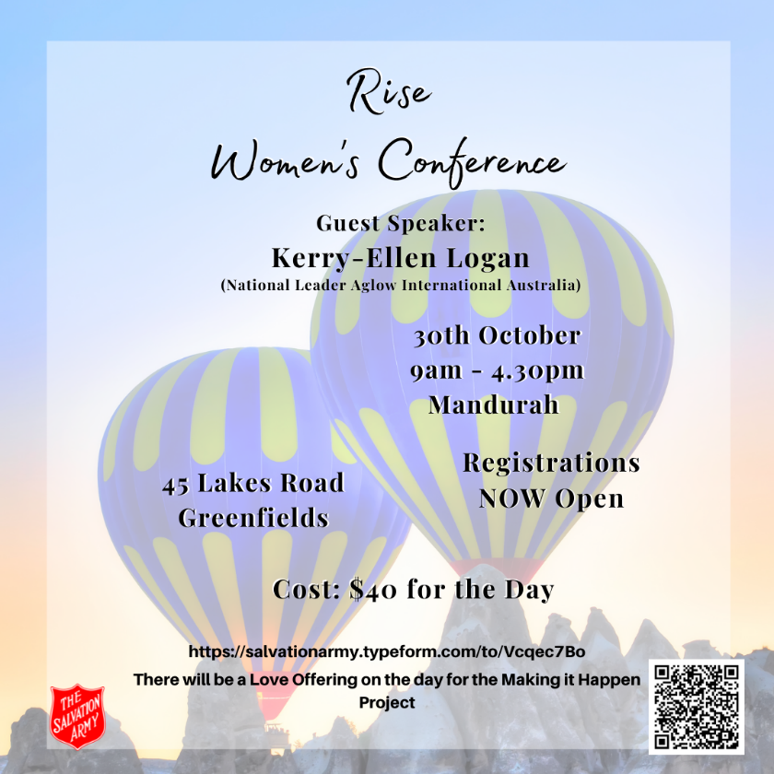
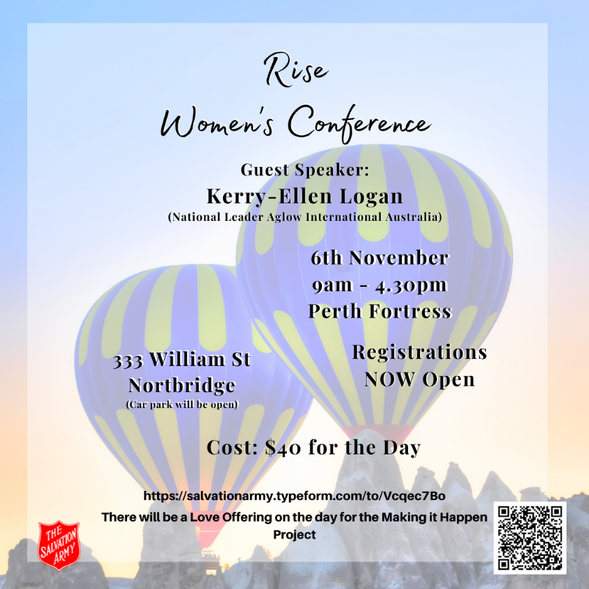

Registration and Medical Form
RISE WOMEN'S CONFERENCE 2021
Cost: $40
Please send your completed form to:
Narelle Wheaton
Level 4, 333 William Street
Northbridge, WA 6003
Or please scan the completed form to: narelle.wheaton@salvationarmy.org.au

WHICH CONFERENCE WILL YOU BE ATTENDING?
MANDURAH (30TH OCTOBER) | PERTH FORTRESS (6TH NOVEMBER)

PERSONAL DETAILS
TITLE
GIVEN NAME | SURNAME
WHAT CORPS/CENTER DO YOU ATTEND
PHONE NO. | MOBILE NO.
EMAIL ADDRESS
STREET ADDRESS | SUBURB
STATE & POSTCODE
IF YOUR POSTAL ADDRESS IS DIFFERENT, PLEASE DETAIL IT HERE

EMERGENCY CONTACTS
EMERGENCY CONTACT NAME | RELATION
BEST CONTACT NUMBER

MEDICAL INFORMATION
DO YOU HAVE A PRE-EXISTING OR PRESENT MEDICAL CONDITION(S)?  Please list each medical condition. | YES/NO
ARE YOU CURRENTLY DEPENDANT ON ANY MEDICATION?  Please list details of all medications including:  -Name of Medication  -Dosage amount | YES/NO
DO YOU HAVE ANY ALLERGIES?  Please list them. | YES/NO
PLEASE LIST ANY DIETARY REQUIREMENTS | YES/NO
DO YOU HAVE ANY ADDITIONAL SPECIAL NEEDS?  E.g. accessibility access.  If so, please list. | YES/NO

LEGALITIES
INDEMNITY/LIABILITY
I understand that all reasonable safety precautions will be taken at all times by The Salvation Army and its leaders, and I agree that those in The Salvation Army connected with organising and operating Rise Women's Conference 2021, cannot be held responsible for personal injury, loss or damage incurred by the submission of this form and attending the event.
MEDICAL TREATMENT
I understand that, if urgent medical attention is needed, every effort will be made to contact the persons listed on this form. In the event that they cannot be contacted in an emergency, I give permission to receive such medical treatment as the staff may deem necessary.
MEDIA CONSENT AND RELEASE
I am willing/I give permission for myself to be photographed or videoed for the purposes of keepsakes or promotional material for the purposes of the event and The Salvation Army generally.
I consent to be photographed and/or recorded. I understand that the image/recording may be displayed in Salvation Army publications/websites.
I ACCEPT / I DO NOT ACCEPT
Please circle.
TERMS AND CONDITIONS
By circling 'I accept', I recognise and accept the risks associated with my attendance and participation at Rise Women's Conference 2021, which includes but is not limited to personal injury, damage to or loss of property.
I understand there are acts and circumstances beyond the control of The Salvation Army. As such, I release and discharge The Salvation Army from any and all claims of loss, damage or harm to property or persons made by me or any other persons as a result of my attendance and/or participation at Rise Women's Conference 2021 and agree that this release and discharge is in respect of any negligent act, breach of duty, default and/or omission by The Salvation Army.
I warrant that I do not have any medical, physical or psychological conditions that would prevent or impair my attendance and/or participation at the Event. I understand that if I cannot provide this assurance, I will give prior notice of my medical conditions to The Salvation Army. I accept that The Salvation Army has sole discretion to allow or limitmy participation in Rise Women's Conference 2021.
I authorise The Salvation Army and its staff to obtain such medical assistance and ambulance transportation for me in the event of illness or injury as they think necessary. I agree to meet all medical expenses associated with such medical assistance or ambulance transportation.
I agree to be bound by and to comply with all of the rules and guidelines issued by The Salvation Army in connection with Rise Women's Conference 2021.
I also understand that The Salvation Army is part of the Christian Church and as such will run this conference acting on those principles and beliefs. The Salvation Army is committed to upholding the Australian Privacy Principles contained in the Privacy Act 1988 (Cth). We recognise the importance of privacy and community awareness regarding the collection, use, disclosure and security of personal and sensitive information which we may collect during the course of our many functions, including Rise Women's Conference 2021.
I ACCEPT / I DO NOT ACCEPT
Please circle.

PRIVACY POLICY
The Salvation Army, a not-for-profit organisation, is committed to upholding its obligations under the Privacy Act 1988.
Our privacy policy can be found online at: https://www.salvationarmy.org.au/about-us/governance-policy/privacy-policy/.
It includes information on how you may access and update the personal information we hold about you, the complaints process for a breach of the Australian Privacy Principles, and how we manage the complaints we receive.
We have a dedicated privacy office responsible for ensuring we adhere to our privacy policy. Their contact details are provided in the privacy policy and are available for your use.
We collect personal information we believe is reasonably necessary to provide you with the services we offer. This includes information you provide to us on this form, any additional information you provide to our staff verbally or otherwise, and any information we may need to collect about you from third parties on your behalf (if applicable).
By providing us with this personal information you also consent to our use or disclosure of this personal information for purposes related to the services we provide. Unless permitted or required by law, we will not use this information for any other purpose without your consent.
By signing this form, you:
- Acknowledge you have read and understood the document
- Understand the reason for the collection of your personal information
- Understand the ways in which your personal information may be used and disclosed
- Acknowledge you provide this personal information to The Salvation Army voluntarily
- Agree to the use and disclosure of your personal information as indicated here
- Acknowledge that the personal information you have provided to us is current
- You undertake to notify us as soon as practicable if this personal information is no longer current or if your consent for the collection and/or use of the personal information is withdrawn.

I ACCEPT / I DO NOT ACCEPT
Please circle.
CANCELLATION NOTICE AND REFUND POLICY
In the event I can no longer attend Rise Women's Conference, I acknowledge that notice is to be given to the event organiser by emailing (narelle.wheaton@salvationarmy.org.au), before 15/10/2021 (for Mandurah) and 22/10/2021 (for Perth Fortress) in order to receive a full refund.
All cancellations received after these dates, will incur the full conference registration fee ($40).
I ACCEPT / I DO NOT ACCEPT
Please circle.
PAYMENT
Please choose how you would like to pay for your registration fees:
CREDIT CARD | NAME ON CARD:  CARD NUMBER: __ __ __ __ / __ __ __ __ / __ __ __ __ / __ __ __ __ /  EXPIRY: __ __ / __ __  CVC: __ __ __
PAYMENT  THROUGH CORPS/CENTRE | IF YOU HAVE SELECTED THIS OPTION ALL YOUR CAMP FEES ARE PAYABLE TO THE SALVATION ARMY. IF YOU SELECT THIS OPTION, YOU AGREE TO SPEAK TO YOUR LOCAL SALVATION ARMY ABOUT PAYMENT.
COST CODE  (VOLUNTEERS/EMPLOYEES) | Please enter the 13 digit cost code to be charged for your registration:  __ __ __ __ __ __ __ __ __ __ __ __ __

AGREEMENT
PLEASE SIGN HERE TO ACKNOWLEDGE YOU HAVE READ THIS FORM CAREFULLY AND HAVE COMPLETED IT TRUTHFULLY.
SIGNATURE | DATE  __ __ / __ __ / __ __ __ __
NAME (PRINTED)

