The Generous Life: Message 1
Sermon Outline: Renewing Hope

Topic: | Handling finances in a godly way
Main Point: | To handle our finances in a godly way we need a strong biblical foundation and apply five principles from Proverbs
Intended Response: | Include God in our finances by applying the five principles

Introduction
How can we grow in our trust to include God in our finances? What do we need to learn in order to feel empowered financially? How do we feel free in an area that often makes people feel stressed, deflated or hopeless?

This sermon begins by laying a balanced, biblical approach to finances then offers five principles to handling finances in a godly way.

- A Biblical foundation
- Everything on this planet belongs to God (Psa 24:1)

Point: We need a firm foundation to have healthy finances

- A balanced approach
- Only one master (Matt 6:24)
- Neither poverty nor riches (Prov 30:7-9)

Point: We need a godly balance when dealing with finance.

- 5 principles to a godly financial plan
- Generating Income (2 Thess 3:10-12)
- Saving Income (Prov 21:20)
- Protecting Income (Lk 14:28)
- Directing Income (Prov 21:5)
- Offering Income (Lk 12:15-21)

Teaching Illustrations and props:
This sermon uses a diagram of a balance beam throughout. You can shows this diagram as part of your PowerPoint slides or you may want to set up a working model using paper. You may also want to run a financial course or small group during this series, to help people write or update their resume, hold prayer meetings for people looking for work, promote Money Care or Employment Plus.

Due to the delicate nature of financial advice, you should mention a disclaimer that this sermon is written from a Biblical viewpoint and is intended to convey God’s perspective on finance. If people are seeking financial advice, they should be recommended to a professional financial service.
More resources for this sermon, including PowerPoint slides are available at www.SArmy.org.au
The Generous Life: Message 1
Sermon: Renewing Hope

Introduction: | Good morning everyone, and welcome to our Sunday service.  Today we are starting a new series called The Generous Life. Over the next four weeks, we are going to explore God’s perspective on finance.  Before we begin, I’d just like to highlight that these sermons are designed to give you insights into God’s perspective on finance. If you do need financial assistance in anyway, I encourage you to seek out professional advice or you can get in contact with Money Care, which is a financial program run by our Doorways ministry.  God has a lot to say about finance. In fact, there are over 2,300 verses on finances in the Bible. 2 out of 3 of the parables Jesus taught used material goods as a way to highlight how we handle money can affect us spiritually.  Learning to handle our finances in a godly way is part of Christian discipleship. And we need to develop a mature approach to money.  Jesus said,  "No one can serve two masters. Either you will hate the one and love the other, or you will be devoted to the one and despise the other. You cannot serve both God and money” (Matt 6:24).  It’s not that money is evil. Money simply takes on the nature of how it is used. So if you are generous with a little, you will be generous with a lot. If you are stingy and greedy with a little you will be stingy and greedy with a lot:  For the love of money is a root of all kinds of evil (1 Tim 6:10).  The phrase “the love of money” means: greed for wealth, covetousness.  Proverbs 30:7-9 describes a mature, balanced approach to money:  “Two things I ask of you, Lord; do not refuse me before I die: Keep falsehood and lies far from me; give me neither poverty nor riches, but give me only my daily bread. Otherwise, I may have too much and disown you and say, ‘Who is the Lord?’ Or I may become poor and steal, and so dishonour the name of my God” (Prov 30:7-9).  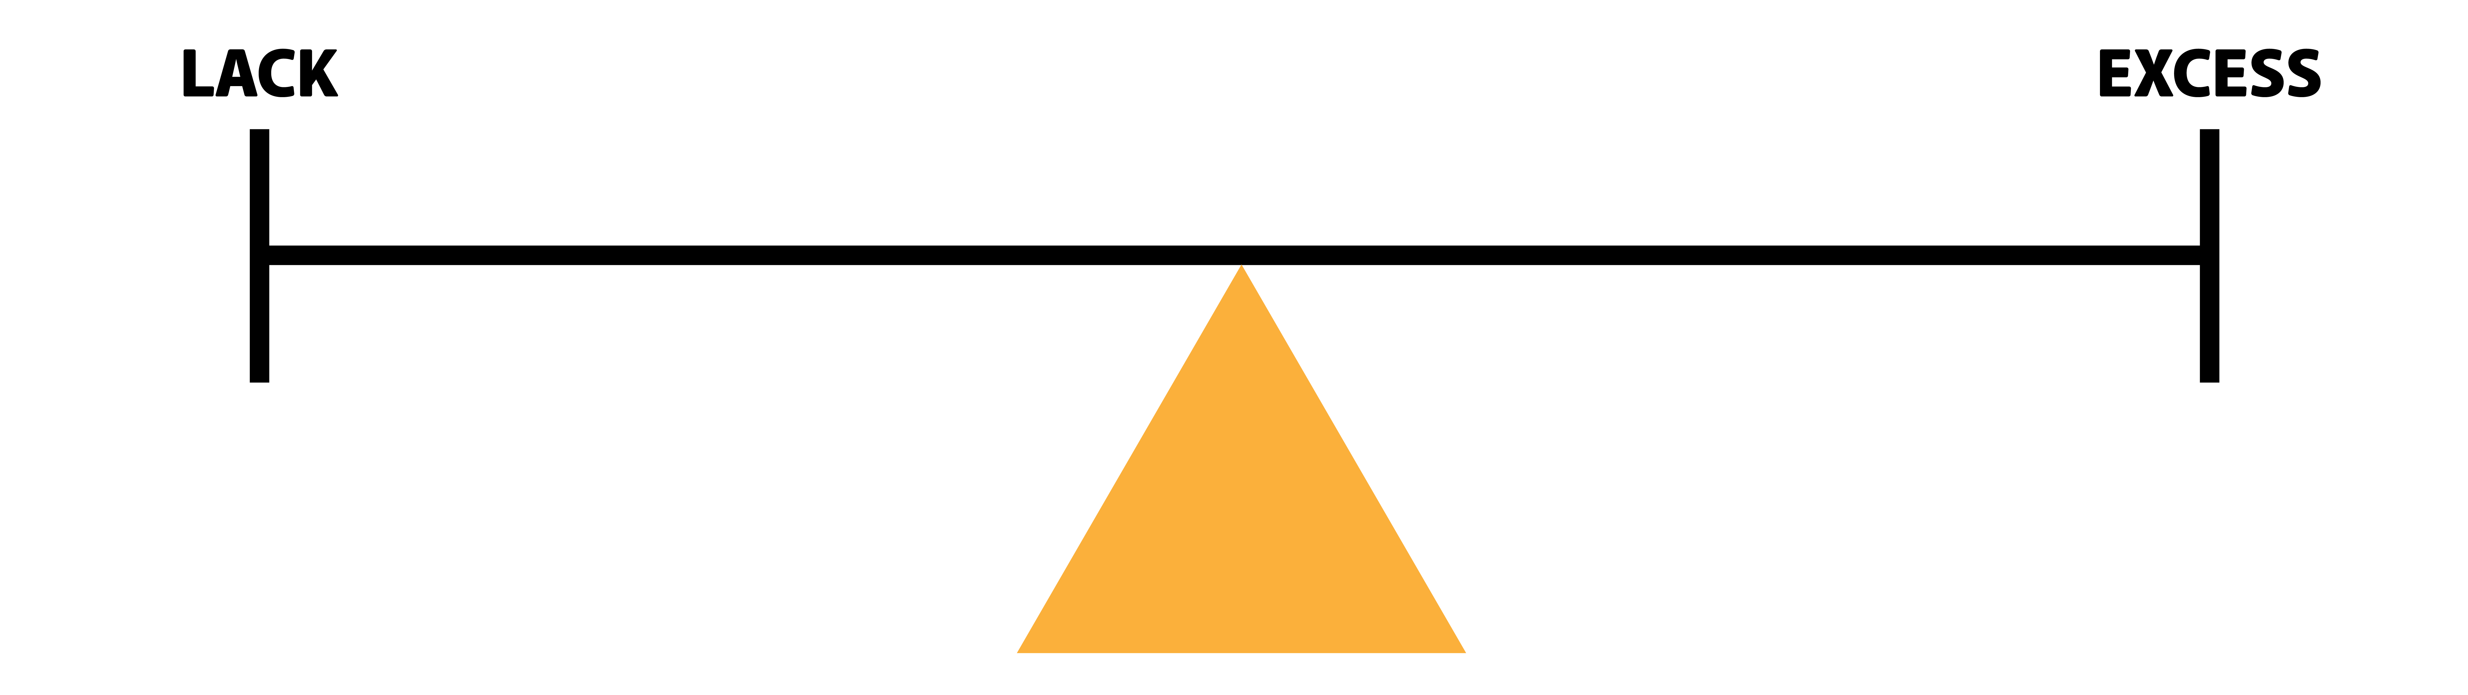  Our goal here today is to learn how to have a godly balance when dealing with finance. We don’t want to live in poverty. Poverty and lack of finance is soul destroying.  But equally, we don’t want to be so focused on money it makes us so greedy that we don’t think of or help others out either. That can lead us down the path of self-reliance and harm our relationship with God.  It’s okay for us to have money and possessions, but it’s not okay for money to have us. God must be first in all things.  So, over the next few weeks I am praying that God will use this series to stretch our faith so we can all grow in our trust in God and include Him more in our financial decisions and habits. I am also praying that you will be equipped with practical tools in order to help you handle your resources in a godly way.  Illustrations: If you have ever watched a home renovation show on TV, you’ll notice the first thing the builders check are the foundations and the supporting beams. These are the two critical areas that determine whether or not the home can be renovated, extended or improved upon. You cannot build without good foundations or good supporting beams.  The same is true for our finances.  Psalm 24:1 says,  “The earth is the LORD's, and everything in it. The world and all its people  belong to him.”  That is our foundation – everything belongs to God. So ‘our’ finances are not really ‘our’ finances – they belong to God and we have to learn how to manage them in a way that honours His name.  Proverbs 24:3 says,  “By wisdom a house is built, and through understanding it is established”.  If we want to handle our finances in a way that honours God, we will need to ensure pillars of godly wisdom are holding up all that we do.
Relevance | I don’t know how money was talked about in your house when you were growing up, or how you talk about it now.  Have you ever felt stressed about money? Have you ever had an argument about money, or felt deflated or hopeless in your situation?  Or have you ever wondered, ‘how can I grow in my faith to trust God with my finances?’ ‘What do we need to learn in order to feel empowered financially?’ ‘How can I stretch my dollar further so I can pay my bills, buy food, get petrol and still have money left over for other basic needs?’ What do I need to do to improve my circumstances?  I’m sure everyone here would like their current financial situation to improve – even if only a little. Due to the demands on our finances, we may feel we don’t have enough money to live on, or have enough give to others, or honour God with.  No matter your current financial situation, be it a time to rebuild, a time to reset, or if you’ve experienced financial ruin, God is a God of hope, of restoration, of blessing.  When we include God things can change for the better.
Transition | The only way forward with finances is if we have a plan. A godly, God honouring, balanced plan.  So how do we build a godly financial plan? How do we maintain a balanced approach in a world focused on self? How do we get the wisdom we need? What does it mean to count the cost?  Thankfully, God has outlined in the Bible at least five pillars we need in our lives to support a financial plan that will stand the test of time and be one that God can bless.  By applying these principles to become better stewards of God’s resources, and over time you will move from feeling stuck and disempowered to having a concrete plan that you feel confident in, because it involves God.  So let’s begin…
Pillar 1:  Work | Generating Income…  Paul said to the church in Thessalonica…  For even when we were with you, we gave you this rule: "The one who is unwilling to work shall not eat." We hear that some among you are idle and disruptive. They are not busy; they are busybodies. Such people we command and urge in the Lord Jesus Christ to settle down and earn the food they eat” (2 Thess 3:10-12).  Work is a wonderful gift. We have been designed to work. There is a funny saying, “there’s a good place to go when you have no money, to work!”  Now, not everyone can work due to personal circumstances but God still expects all of us to have a good work ethic and approach to life…  One who is slack in his work is brother to one who destroys.  (Prov 18:9)  Finding a job can be difficult in today’s climate. But we can pray together. We can help each other with writing a resume. Any legal job is good for it allows us to budget with predictable income. We can figure out how much is coming in, how much is going out, and the space in the middle is for savings.  Prayer: you may want to hold a series of prayer meetings for people in your church who are looking for work, or find people in the congregation who can help others create a resume and find a job.
Principle 1 | We need a plan for generating income – work.
Transition | The next pillar we need is Savings plan…
Pillar 2: Savings | Saving Income…  Have you ever been caught out by an emergency and didn’t have the money to pay for it? The flat tyre, a surprise trip to the dentist or the unexpected bill.  According to Scripture, wise people have savings:  Proverbs 21:20  “The wise store up choice food and olive oil, but fools gulp theirs down.”  Proverbs 13:22  A good person leaves an inheritance for their children's children…  Even ants save,  Take a lesson from the ants, you lazybones. Learn from their ways and become wise! Though they have no prince or governor or ruler to make them work, they labour hard all summer, gathering food for the winter.  (Prov 6:8)  Without savings, there’s every possibility you’ll end up borrowing money from someone to cover the expense, and that puts you into debt. Again, getting out of debt and staying out of debt is a key pillar in financial freedom.  A good rule is tithe 10%, save 10%, live off 80%.
Principle 2 | We need a savings plan.
Transition | The next pillar we need is a plan for our debt. This is about protecting our income…
Pillar 3: Avoiding Debt | Protecting Income…  One of the best ways to begin to protect your finance is to avoid irresponsible debt.  By that I mean  - Debt you cannot meet the repayments of comfortably,  - Debt that stops you giving,  - Debt that impacts basics daily needs: food, shelter, clothing,  - Debt that robs you of financial peace.  There are many stories in the news about people who have got themselves into uncontrollable and unmanageable debt and have lost everything as a result.  They buy on 24 month interest free – the furniture, the big screen TV, the latest gadgets – only to find themselves 25 months later owing more than they borrowed.  It’s unwise to have this type of debt.  Some debt is helpful, like having a mortgage or education debt – this debt may be needed for a season but again, only if you can afford it. There’s no point getting a house if you can’t afford the mortgage. Again, the news is full of stories of people who lose their house because they’ve defaulted on the repayments.  Sadly, there are so many stories of lives that have been financially ruined because people spent money they didn’t really have. They wanted the benefits of a balanced life, but instead ended up in severe lack because as soon as they earned money – whoosh – it goes straight out the door on repayments.  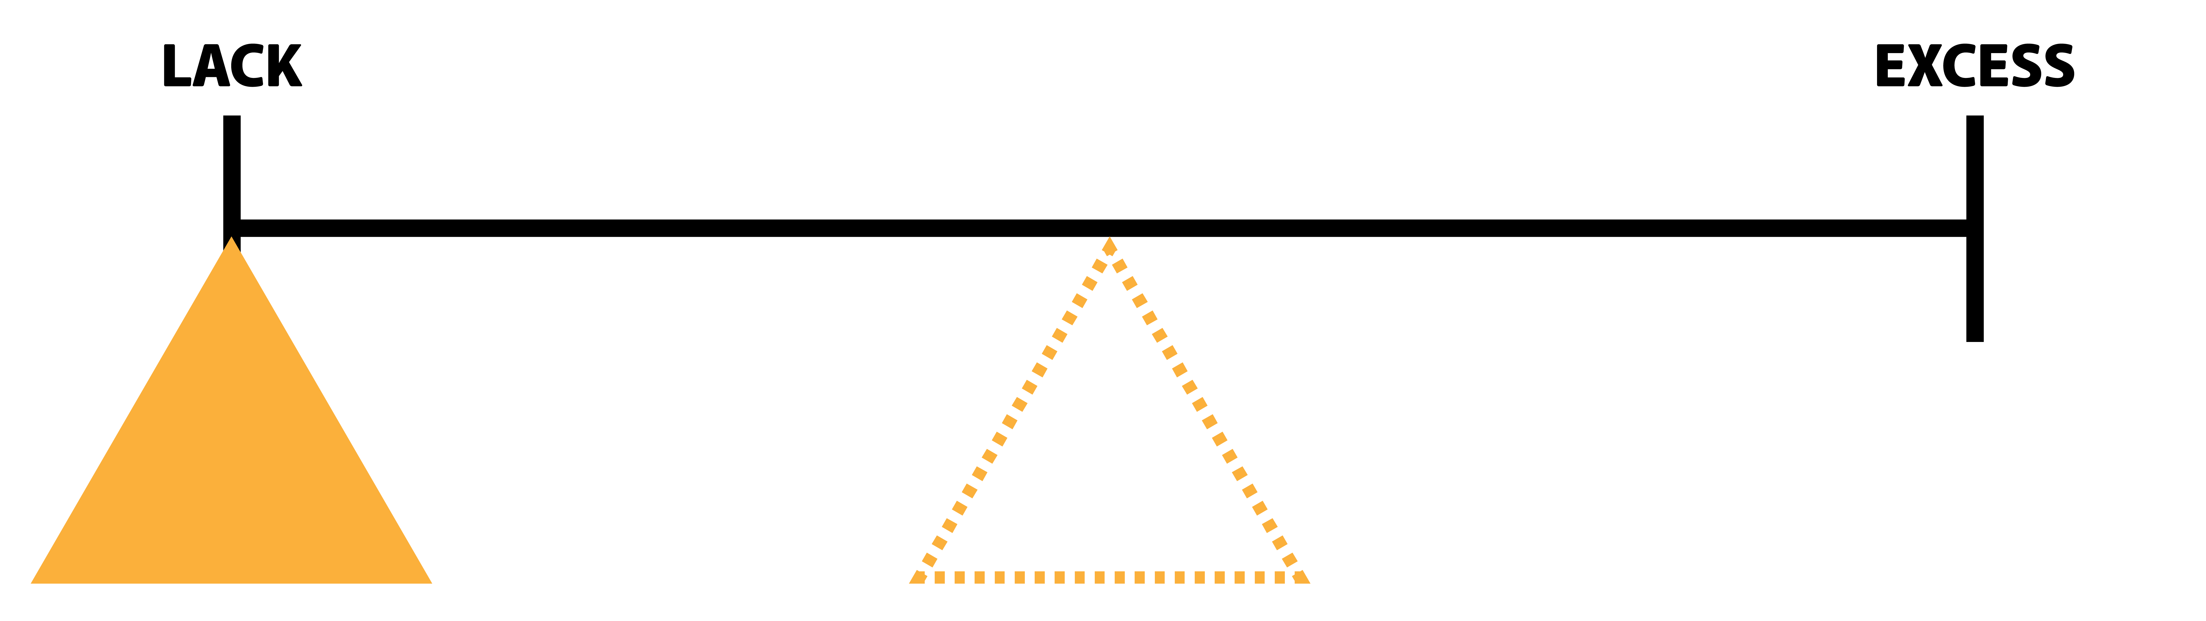  Do you ever feel like money comes in the front door and goes out the backdoor, out the windows, the vents, the floorboards, any opening it has and whoosh – the money’s gone! You earn money, but never see it.  Bill Hybles has a challenging quote, “debt is getting ahead of God’s provision for our lives”.  Debt has a way of trapping us into a financial cycle that’s hard to break. Dave Ramsay says, “you can wander into debt, but you cannot wander out of it”  We need to have a plan to avoid getting into irresponsible debt as much as we can and protect our income from others who have a plan for us to spend more than we earn.  Jesus said,  "Suppose one of you wants to build a tower. Won't you first sit down and count the cost to see if you have enough money to complete it?”  (Lk 14:28).  We need to ask ourselves:  - Can I really afford this? There’s a really simple way to check if you can afford something – you have the cash to pay for it.  - Am I trusting God?  God will make sure we have what we need. He will provide for us.  - Am I counting the cost – Am I being a wise steward?  We need to prioritise our spending, and God will guide us in this.  We also need to have a plan to get out of debt.  Speaking about getting out of debt, Proverbs 6:1-5 says in The Message translation:  Dear friend, if you’ve gone into hock with your neighbour or locked yourself into a deal with a stranger, if you’ve impulsively promised the shirt off your back and now find yourself shivering out in the cold, Friend, don’t waste a minute, get yourself out of that mess. You’re in that man’s clutches! Go, put on a long face; act desperate. Don’t procrastinate there’s no time to lose. Run like a deer from the hunter, fly like a bird from the trapper!  (Prov 6:1-5 MSG).  We can wander into debt but we can’t wander out of it. Now, debt is not sin, but the Bible is pretty strong on this subject:  The rich rule over the poor, and the borrower is slave to the lender  (Prov 22:7).  The word slave means: bondage, slavery, without rights, trapped.  Paul says in Romans 13:8,  Let no debt remain outstanding, except the continuing debt to love one another, for whoever loves others has fulfilled the law.  Dave Ramsay says, “finance is 80% behaviour”. We don’t need to have a degree in mathematics, we just need the fruit of the Holy Spirit.  When we are temperate, self-controlled, disciplined – we can avoid debt and our finances can be turned around. And God can help us with this.  If anyone here is struggling, or would like some advice in this area, we have financial counsellors who can help you. Please come and speak to us at the end of this service and we can refer you on to the right person.
Principle 3 | We need a plan for protecting our income against debt.
Transition | The fourth pillar is budgeting
Pillar 4:  Budget | Directing Income (develop a budget)…  John Maxwell says, “A budget is telling your money where to go so you don’t need to wonder where it went”.  Everyone else has a plan for your money: the shops, the supermarket, clothing labels, advertising companies.  On average we are bombarded with more than 3,000 ads per day with the sole aim of influencing us to spend our money on what they are selling.  And that’s fine. It’s good to buy things. But if we don’t have a plan, we will end up buying more than we need, spending more than we have, or buying items that we don’t really need. Then, because there’s not enough left over, stress begins to creep in. Worry about bills begins to mount up.  This principle is crucial: We need a plan for our income. We need a budget: a simple system that directs our money in the way we want it to go.  Proverbs 27:23 says,  Be sure you know the condition of your flocks, give careful attention to your herds;  We need to know the state of our finances – a budget will tell us that.  The Bible also tells us,  The plans of the diligent lead to profit as surely as haste leads to poverty (Prov 21:5).  ‘The plans of the diligent’ – we need to know the details of our incomings and outgoings, otherwise we will end up with very little. Again, that’s what a budget is designed to do.  Insert program or help: If you would like help putting a budget together, we run a program called Help Care where some who is trained can help you.
Principle 4 | We need a plan for our income – we need a budget.
Transition | The final principle is we need a plan for giving.
Pillar 5:  Giving | Offering Income…  Over the next few weeks we will explore this pillar in detail. But the bottom line is God is giver (Jn 3:16). If we want to reflect God’s nature we need to give.  This might be the most important pillar of all. Jesus told a parable, about a man who had successfully managed four of the pillars:  “The ground of a certain rich man yielded an abundant harvest. He thought to himself, ‘What shall I do? I have no place to store my crops.’  “Then he said, ‘This is what I’ll do. I will tear down my barns and build bigger ones, and there I will store my surplus grain. And I’ll say to myself, “You have plenty of grain laid up for many years. Take life easy; eat, drink and be merry.” ’  - This man had a plan for his income – he knew exactly what he had.  - He didn’t seem to have any debt. He had land. A farm. a harvest that he could do what he wanted with. The harvest had his name on it, no one else’s.  - He had plenty of savings for he had grain laid up for many years.  - He had income. A farm. Real estate. A retirement plan.  - This all seems good, but God calls him a ‘fool’?  He seemed to have excess for years ahead…  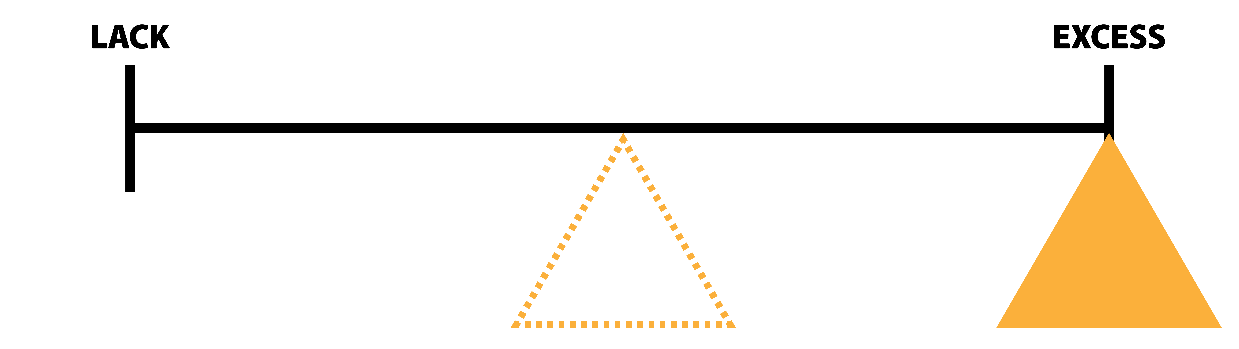  “But God said to him, ‘You fool! This very night your life will be demanded from you. Then who will get what you have prepared for yourself?’ “This is how it will be with whoever stores up things for themselves but is not rich toward God”  (Lk 12:16-21)  He had steps 1 -4 but not 5. For all the room he had in his barns, he had no room for others.  He didn’t have a good foundation – “The Earth is the Lord’s and everything in it” Psalm 24:1. He thought he could keep it all to himself, in his excess he became selfish and he had forgotten that his soul belonged to God.  Our lives are not our own. We belong to God. And God calls us to help others. To give to the poor and needy. To share our resources with others. To be wise – yes – but to be generous as well.  We need a plan for our giving, because it’s not something we naturally do well, or remember that well when the bills come in, and the kids are hungry, and the credit card needs to be paid. We need to intentionally give.
Principle 5 | We need a plan for our giving.
Transition | Building a healthy financial plan takes time. It takes time to create a budget. To get out of debt, to save and to work hard. But overtime if we do these things, we will be able to give to others, to mission, and see God bless our finances.
Hope | As we close today, let me encourage you - we have a great hope in God.  God can rebuild ruins if we include Him. If you feel you may have drifted in your finances and need to get back on track, God will guide you. There is no situation God cannot turn around.  We don’t need to do this alone, or in our own strength. The Bible says,  “Unless the Lord builds the house, the builders labour in vain” (Psalm 127:1)  Let’s include God in our finances.
Call to Action | If you are just visiting here today, or have not made a decision to commit your life to Christ, I invite you to make Him your Lord and Saviour.  There’s more to life than earning and keeping money,  Cast but a glance at riches, and they are gone, for they will surely sprout wings and fly off to the sky like an eagle (Prov 23:5).  One day we will all stand before God and give an account for our lives. I am reminded of the words of Jesus,  “Do not store up for yourselves treasures on earth, where moths destroy, and where thieves break in and steal. But store up for yourselves treasures in heaven, where moths do not destroy, and where thieves do not break in and steal. For where your treasure is, there your heart will be also.  (Matt 6:19-21)  The greatest treasure anyone of us can have is salvation. True riches is the experience of walking with God.  I invite you to pray with me…
Prayer | Father God, you are our hope and you can turn any situation around.  Today, we look to you as Jehovah Jireh – our provider. Lord, we invite you into our finances and ask that you would help us handle our resources in a way that pleases you.  Father, where there is ruin we ask you would help rebuild. Where there is lack, we ask that you would provide. Where there is abundance, we ask that you would guide.  In all things, we look to you for your grace and provisions – Amen.

The Generous Life: Message 1
Scriptures: Renewing Hope

Prov 24:3
“By wisdom a house is built, and through understanding it is established”

Lk 14:28
"Suppose one of you wants to build a tower. Won't you first sit down and estimate the cost to see if you have enough money to complete it?”

Prov 21:5
The plans of the diligent lead to profit as surely as haste leads to poverty

Prov 27:23
Be sure you know the condition of your flocks, give careful attention to your herds

Prov 30:7-9
“Two things I ask of you, Lord; do not refuse me before I die: Keep falsehood and lies far from me; give me neither poverty nor riches, but give me only my daily bread. Otherwise, I may have too much and disown you and say, ‘Who is the Lord?’ Or I may become poor and steal, and so dishonour the name of my God”

Matt 6:24
No one can serve two masters. Either you will hate the one and love the other, or you will be devoted to the one and despise the other. You cannot serve both God and money”

1 Tim 6:10
For the love of money is a root of all kinds of evil

Prov 6:1-5 MSG
Dear friend, if you’ve gone into hock with your neighbour or locked yourself into a deal with a stranger, If you’ve impulsively promised the shirt off your back and now find yourself shivering out in the cold, Friend, don’t waste a minute, get yourself out of that mess. You’re in that man’s clutches! Go, put on a long face; act desperate. Don’t procrastinate there’s no time to lose. Run like a deer from the hunter, fly like a bird from the trapper!

Rom 13:8
Let no debt remain outstanding, except the continuing debt to love one another, for whoever loves others has fulfilled the law

Prov 6:8
Take a lesson from the ants, you lazybones. Learn from their ways and become wise! Though they have no prince or governor or ruler to make them work, they labor hard all summer, gathering food for the winter

Prov 21:20
“The wise store up choice food and olive oil, but fools gulp theirs down”
Prov 13:22
A good person leaves an inheritance for their children's children, but a sinner's wealth is stored up for the righteous.

Prov 18:9
One who is slack in his work is brother to one who destroys

2 Thess 3:10-12
For even when we were with you, we gave you this rule: "The one who is unwilling to work shall not eat." We hear that some among you are idle and disruptive. They are not busy; they are busybodies. Such people we command and urge in the Lord Jesus Christ to settle down and earn the food they eat”

Psa 127:1
Unless the Lord builds the house, the builders labour in vain”

Gen 22:13-14
Abraham looked up and there in a thicket he saw a ram caught by its horns. He went over and took the ram and sacrificed it as a burnt offering instead of his son. So Abraham called that place The LORD Will Provide

Matt 17:24-7
When they came to Capernaum, those who collected the two-drachma tax came to Peter and said, “Does your teacher not pay the two-drachma tax?” He said, “Yes.” And when he came into the house, Jesus spoke to him first, saying, “What do you think, Simon? From whom do the kings of the earth collect customs or poll-tax, from their sons or from strangers?” When Peter said, “From strangers,” Jesus said to him, “Then the sons are exempt. “However, so that we do not offend them, go to the sea and throw in a hook, and take the first fish that comes up; and when you open its mouth, you will find a shekel. Take that and give it to them for you and Me”

Prov 23:5
Cast but a glance at riches, and they are gone, for they will surely sprout wings and fly off to the sky like an eagle

Matt 6:19-21
“Do not store up for yourselves treasures on earth, where moths and vermin destroy, and where thieves break in and steal. But store up for yourselves treasures in heaven, where moths and vermin do not destroy, and where thieves do not break in and steal. For where your treasure is, there your heart will be also.

Jn 14:1-4
“Do not let your hearts be troubled. You believe in God ; believe also in me. My Father’s house has many rooms; if that were not so, would I have told you that I am going there to prepare a place for you? And if I go and prepare a place for you, I will come back and take you to be with me that you also may be where I am. You know the way to the place where I am going”

