Sunday 14th May 2020
Exodus 19:2 – 8a – The Covent Between God and Israel

If you have ever had a look at the satellite images on Google Maps of the path the Israelites took from Egypt to the Promise Land you can see that the land is very rocky, dry and covered in mountains and hills. In modern times, a trip from Cairo to Jerusalem in a car can take over nine hours. Walking the same path a person could do the 727km tip is 2-3 weeks, however, this modern day path is going through the mountains. If you have ever seen bible maps of the Israelites journey, you will see that they had to down and around the mountain area, making their trip much longer.
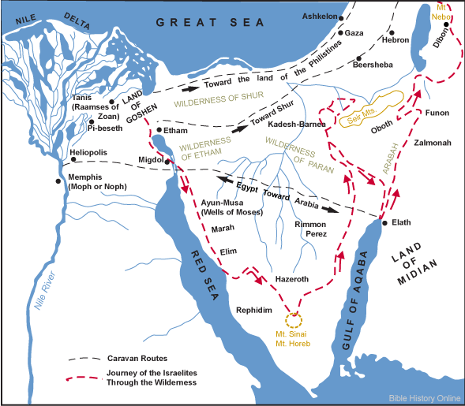
Image taken from https://www.bible-history.com/maps/route_exodus.html
In our scripture reading today, we pick up with the Israelites during their third month of journeying after their escape from Egypt. After departing Rephidim, the Israelites have just entered the wilderness of Sinai, the desert area around Mount Sinai, the Mount where Moses had encountered the burning bush.
.
In verse 3 we see that Moses has once again climbed the mountain to speak and receive further instructions from God. Verse 4 is a reminder to the Israelites of all that God has done for them. By this point in time the Israelites have had a long and slow journey where they have been lead out of Egypt (Ex. 13-15), seen the splitting of the Red Sea and deliverance from the Egyptian soldiers (Ex. 14), had bitter water at Marah (Ex. 15:22-27), a lack of bread and meat (Ex. 16) and a lack of water at Rephidim (17:1-7). In each instance, God had provided for the Israelites, making sure that they had enough food and water and safety.
God uses the imagery of the eagle that like parent eagles who carry their young on their backs, God himself has also carried the Israelites from their oppression and have provided them with provisions, like an adult eagle for their young. The Israelites are once again free like an eagle’s freedom in the sky.
Verses 5 and 6 then shows God’s new promise to the Israelites.
‘Now if you will obey me and keep my covenant, you will be my own special treasure from among all the peoples on earth; for all the earth belongs to me. And you will be my kingdom of priests, my holy nation.’
This new promise is quite simple; God has claimed the people of Israel as his own, if the people can obey His convent and keeps trusting in Him always, then they will be set apart from other nations. They will be raised above the other nations as God’s holy people. This is an additional promise and reiteration of the promise that God made to Abraham in Genesis 17, of providing the Promise Land and setting apart Abraham’s descendants as God’s people.
It is also to note in verse 6 that God said that they people of Israel would be a kingdom of priest, my holy nation. This is God claiming that he is our one true king; no one was to be higher than the other, except for him. God had intended that every believer could come to God themselves, and that everyone could represent God to the nations. Peter in 1 Peter 2:9 reminds us that we are to be the royal priesthood.
The last two verses of out reading show us that Moses descends the mountain to gather the people and gathers the people to give them the instructions that God had given them. The people as one respond together “We will do everything the Lord has commanded.” Moses then returns to the top of the mountain to give God the people’s answer, thus sealing the covenant and promise.
This is neither the first time nor the last time that the convent and promise is made between God and the Israelites. We know from the scriptures that that the Israelites still have a long and challenging time ahead, they will complain, break the ten commandments and have many other things occur before they finally reach the Promise Land, but all through this, God never breaks his promise. He remains with the Israelites and fulfills his promise to make the Israelites his holy nation, his people.
God shows us that he has the plan, he provides for us always. He never leaves us and he never breaks his promises to us. Yes, things may not happen in the way that we plan it, it definitely didn’t happen in the way the Israelites thought things would occur, but he is always in control. We need to remain strong in our faith for God and trust that he knows what to do. We are his people.
Where are you in your faith journey today?
Have you given God full control to God in everything that you are facing in life?
Are you trusting and obeying God instructions to your life?

