
Safe from the Start

KIT ORDER FORM

ACCOUNT TO: DATE: ………………………….……………….

ORGANISATION: ………………………………………………………………………………….………….. CONTACT PERSON: ………………………………………………………………..

ADDRESS: …………………………………………………………………………………………………………………………………………………………………………………………………………..

SUBURB: ………………………………………………………………………………………………………………… STATE: ………………………………. POST CODE: ………………………..

TELEPHONE NUMBER: ………………………………………..…………………………………………………………………………………………………………………………………….........

EMAIL ADDRESS: ……………………………………………………………………………………………………………………………………………..…………………………….……………..…

Qty | Title | Total (incl gst)
 | Safe from the Start Resource Kit $550.00 each (plus gst) | $605.00
 | Postage (within Australia) $40 per kit | $
Includes:
Hints & Tips – using the resources in ‘activity based play’
34 resources: books, puppets, CD, DVD, activity book, cards, language ball
Safe from the Start Activity Based Play DVD & Baptcare ‘Not in My House’ DVD
2 brochures, 2 posters, Duluth Wheels
 | Additional Duluth Wheels (set of 2, double sided) $1 per set 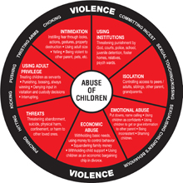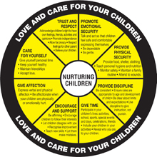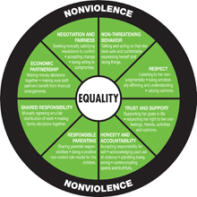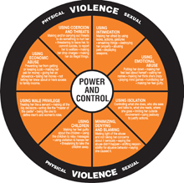
Additional Brochures – FV Can Harm Your Child For Life 65c each
Seeing, hearing and feeling violence 25c each
 | Additional Posters (set of 2) $1 per set, Safe from the Start DVD $10, Not in My House $10
TOTAL (including GST) |  | $

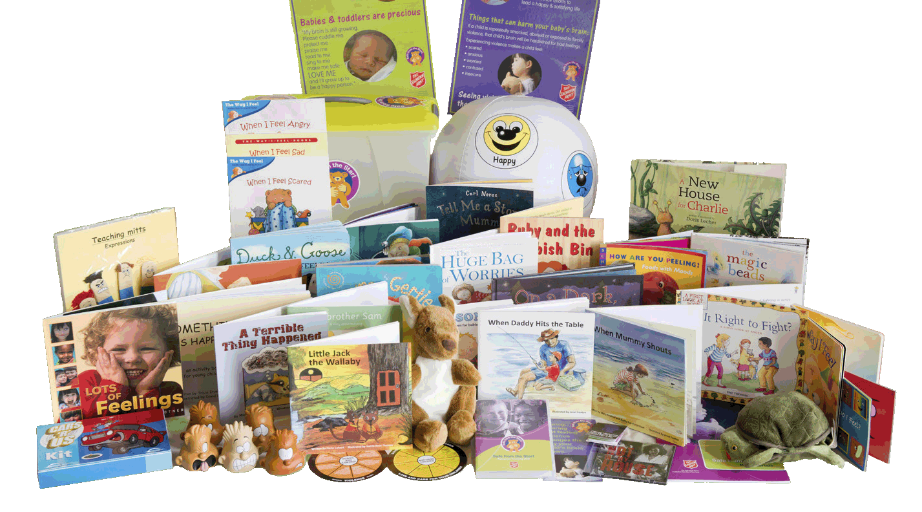
Email:
safefromthestart@aus.salvationarmy.org

Enquiries to:
P: 03 6228 8423

Website:
www.salvationarmy.org.au/safefromthestart


Project funded by Commonwealth Office for Women, Tasmanian Community Fund & The Salvation Army Tasmania.

