
Safe from the Start Project

ORDER FORM

Organisation: ………………………………………………………………………………………………….……………………
Contact person: ………………………………….………………. Position title: ……………………………….……….….
Address: ………………………………………………………………………………………………………………………………
Suburb: …………………………… State: ……………… Post code: ……………………………………….
Telephone No.: ………………………………………….. Fax No.: ………………………………………….
Email address: …………………………………………………………………………………………………..
Qty | Title | Total (including GST)
 | 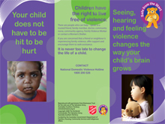 Seeing, hearing and feeling violence flyer – 25c ea | $
 | 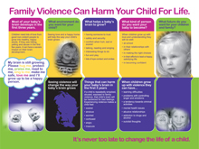 Family Violence Can Harm Your Child For Life brochure – 65c ea | $
 | 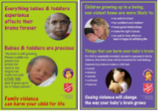 Posters (set of 2) $1.00/set | $
 | 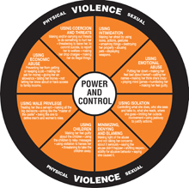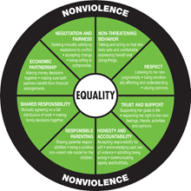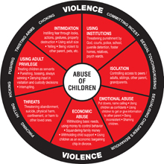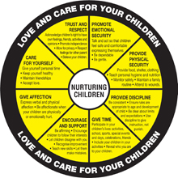‘Duluth Wheels’ $1.00/set (double-sided) | $
 | SUBTOTAL | $
 | Postage (will vary depending on quantity and location)
 | TOTAL



Email or Fax to:

F: 03 6228 8499
E: safefromthestart@aus.salvationarmy.org

Enquiries to:
P: 03 6228 8423
W: salvationarmy.org.au/safefromthestart

Project funded by Commonwealth Office for Women, Tasmanian Early Years Foundation and The Salvation Army Tasmania.

